DRAFT
Best Management Practices for Ranching in
Sonoran Desert Tortoise (Gopherus morafkai) Habitat in Arizona

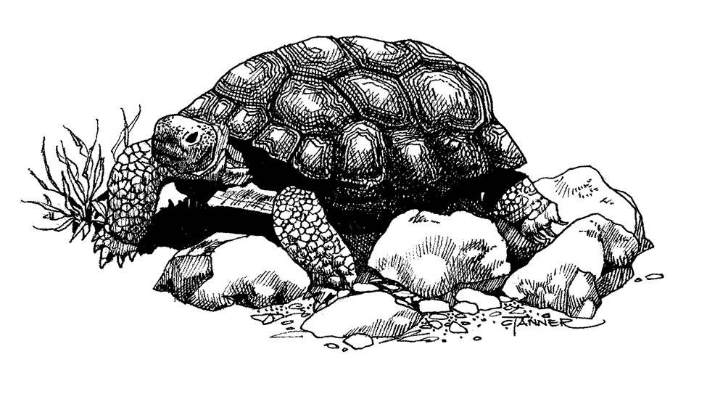

Prepared By The
Ranching and Sonoran Desert Tortoise Working Group
2014
Recommended Citation

Ranching and Sonoran Desert Tortoise Working Group. Draft. Best Management Practices for Ranching in Sonoran desert tortoise (Gopherus morafkai) habitat in Arizona. 41 pp. plus appendices.

Acknowledgements

The Ranching and Sonoran Desert Tortoise Working Group consists of the following agencies and their representatives:

Agency | Representative
Arizona Game and Fish Department, Nongame Wildlife Branch | Cristina Jones  Audria
Arizona Association of Natural Resource Conservation Districts Association  Association State Association | Stefanie Smallhouse
U.S. Bureau of Land Management, Phoenix | Bill Coulloudon
 | Tim Hughes
U. S. Department of Agriculture Natural Resources Conservation Service | Steve Barker
Service | Larry D. Ellicott
 | Byron Lambeth
 | Stu Tuttle
U. S. Fish and Wildlife Service, Arizona Services Office | Jeff Servoss
 | Brian Wooldridge
Winkelman Natural Resource Conservation District | Bill Dunn
 | Francie Meyer
 | W. Walter Meyer

Dedication

In memory of Larry D. Ellicott, retired State NRCS Range Specialist and Icon of Range Management
Special Thanks

We thank the Arizona Game and Fish Department’s Global Information System Program for providing the range map, and all those who reviewed this document and provided meaningful comments. We also thank J. D. Riedle, B. K. Sullivan, and K. E. Cline for providing photos for the photographic guide to tortoise sign. In addition, we sincerely appreciate Steve Spangle for his encouragement to form this team, and his continued support throughout the process.

Cover Artwork

Cindy Tanner

Executive Summary

On December 13, 2010, the U.S. Fish and Wildlife Service, (FWS) issued a positive 12-month finding in the Federal Register that Sonoran desert tortoise (Gopherus morafkai)(SDT) warrants protection under the Endangered Species Act (ESA) but is precluded by the need to address other higher priorities. The SDT was added to the list of candidates for ESA protection where its status is reviewed annually. Livestock grazing in Arizona is actively managed, and FWS found that, while grazing effects to SDT may occur, potential effects of livestock grazing are limited in severity and scope. Although grazing was not listed as a threat in Arizona, the Ranching and Sonoran Desert Tortoise Working Group (Working Group) formed in 2011 to conserve existing SDT populations, provide conservation measures to offset potential effects, and possibly preclude the need to list the species under the ESA in the future. The Working Group is composed of ranchers and resource specialists from a variety of land and resource management agencies, and is a collaborative effort that fosters cooperation and exchange of information, and identifies appropriate voluntary conservation measures that would reduce or eliminate consultation for ranching activities if the species were to be listed. This effort also serves to be a proactive and voluntary approach by the ranching industry in working with agencies to actively conserve SDT and its habitat.

This document has been developed to facilitate the implementation of conservation measures for SDT on livestock ranches in Arizona providing the mutual assurance that working rangelands can support the long-term survival of the species. It is not intended to replace existing conservation and management plans that are designed for SDT or their habitat. This document does not supersede land management agency authorities, regulations and policies. Rather, the document is intended to enhance the effectiveness of those activities within livestock ranches, and may serve as a template for identifying and implementing conservation measures for other species also occurring on rangelands.
Table of Contents
Introduction 1
Purpose and Need 1
Sonoran Desert Tortoise Natural History 2
Taxonomy and Range 2
Habitat 3
Elevation 3
Description 3
Seasonal Behavior and Long Distance Movements 3
Shelter Use 5
Reproduction 5
Longevity 6
Bladder Physiology 6
Predation 7
Diet, Foraging Behavior, and Potassium Excretion Potential 7
Key Habitat Features 9
Planning for Ranch Management Activities in Sonoran Desert Tortoise Habitat 9
Ranch Planning Section I: General Conservation Measures 10
Ranch Planning Section II: Potential Resource Effects to Sonoran Desert Tortoises or Their Habitat as Related to Ranch Activities and Conservation Practices 11
Channel/Streambank/Shoreline Modification 12
Vegetation Modification 12
Ground Disturbance 13
Human Disturbance 14
Barrier/Hazard 14
Nonnative/Invasive Species Introduction 15
Ranch Planning Section III: Grazing Systems and Associated Ranch Activities 15
Managed Grazing 16
Locating Corrals (Temporary and Permanent), Corral Maintenance 17
Supplemental Feeding, Placing Salt, Temporary Waters 17
Driving on Established Roads and Trails 18
Off-road Travel 18
Inventory and Monitoring 18
Predator Control 19
Ranch Planning Section IV: Conservation Practices Specific to NRCS Programs 19
Access Control 19
Brush Management 19
Channel Stabilization 20
Clearing and Snagging 20
Critical Area Planting 21
Early Successional Habitat Development/Management 21
Fence 22
Grade Stabilization Structure 22
Heavy Use Area Protection 23

Herbaceous Weed Control 23
Land Clearing 24
Obstruction Removal 24
Pipeline 24
Pond 25
Pumping Plant 25
Range Planting 25
Restoration and Management of Rare and Declining Habitats 26
Spring Development 26
Structure for Water Control 27
Tree/Shrub Establishment 27
Tree/Shrub Site Preparation 28
Upland Wildlife Habitat Management 28
Water Harvesting Catchment 28
Water Well 29
Watering Facility 29
Water spreading 30
Glossary 31
Literature Cited 36

Appendix A: Distribution of Sonoran Desert Tortoise in Arizona 42
Appendix B: Photographic Examples of Tortoise Sign 43
Appendix C: Guidelines for Handling Sonoran Desert Tortoises 55
Appendix D: Resource Concerns on Rangeland Addressed with Conservation Practices by NRCS 56
Appendix E: Desert Tortoise Survey Guidelines for Environmental Consultants 58
Appendix F: List Of Locally Adapted, Important Forage And Cover Plants For Sonoran Desert Tortoises 59
Appendix G: Invasive Nonnative Plants That Threaten Wildlands in Arizona 60
Appendix H: Recommended Specifications for Desert Tortoise Exclusion Fencing 61
Appendix I: Guidelines for Temporary and Permanent Tortoise Friendly Cattle
Guards 66

DRAFT BEST MANAGEMENT PRACTICES FOR RANCHING IN SONORAN DESERT TORTOISE (Gopherus morafkai) HABITAT in Arizona

Introduction

Purpose and Need

In 1989, the Mojave population of the desert tortoise was emergency listed as endangered under the Endangered Species Act (ESA). Based on the best data available and conservation actions being implemented at the time, the status was changed to threatened in 1990. In the following year, the U.S. Fish and Wildlife Service (FWS) issued a 12-month finding that stated the Sonoran population of the desert tortoise did not warrant listing, citing both a lack of evidence for pandemic disease such that had impacted Mojave desert tortoise populations and the existence of disjunct populations that should limit the spread of disease. Because there are ecological differences between Mojave and Sonoran populations, disturbance to habitat was thought to be less severe to the Sonoran population (FWS 1991). Evidence of healthy populations in Mexico also contributed to the 1991 FWS finding. In 2002, Forest Guardians (now known as WildEarth Guardians) petitioned numerous agencies for data on the Sonoran population of the desert tortoise under the Freedom of Information Act. The basis for this request was to evaluate the data and to petition to list the Sonoran population of desert tortoises under the ESA. In 2008, WildEarth Guardians and Western Watersheds Project petitioned to list the Sonoran population of the desert tortoise. On August 28, 2009, FWS issued a positive 90-day finding in the Federal Register that the petition presented substantial new information indicating that listing may be warranted, and provided notice of the initiation of a 12-month status review (FWS 2009).

As stated in the FWS Review, effects attributed to livestock grazing may include destruction of vegetation, alteration of soil, competition for food, and destruction of burrows (FWS 2010). These effects may be attenuated by the fact that livestock grazing in Arizona is actively managed (FWS 2010) and presumed to be less of an impact to tortoise populations that largely occur in steeper topography (FWS 2010). However, the impact of livestock grazing may be more significant lower on slopes or within dispersal corridors between mountains or hillsides (FWS 2010). Mortality from crushing may also occur, however the results of a study conducted by Balph and Malecheck (1985) concluded that cattle avoid stepping on uneven surfaces. Desert tortoises will likely be perceived as an uneven ground surface to cattle; therefore, cattle may intentionally avoid stepping on them. While negative effects of grazing have been suggested, there is scant evidence that any have had a significant impact on SDT populations, and this is especially true of current managed grazing.

This document develops a Best Management Practices strategy to facilitate the implementation of conservation measures for Sonoran desert tortoise (Gopherus morafkai, formerly G. agassizii) on livestock ranches in Arizona. This is a collaborative and cooperative effort among individual ranchers, resource agencies, and governments and fosters cooperation and exchange of information, identifies appropriate conservation efforts, and voluntarily reduces potential threats and therefore improves the species status. The Ranching and Sonoran Desert Tortoise Working Group (Working Group) was established in 2011 in response to the positive 12-month finding through which Sonoran desert tortoise (SDT) became a candidate for listing under the ESA. In the 12-month finding (2010) and annual candidate notice of review (2013) for the SDT, the FWS concluded that, while livestock grazing may affect SDT, those effects are likely limited in severity and scope in Arizona because livestock grazing is actively managed by land management agencies and the habitat shared by livestock and SDT is not a significant proportion of the SDT range in most areas in Arizona (FWS 2010). To assist livestock producers in efforts to ensure the long-term survival of SDT, the Working Group held multiple meetings to identify activities associated with livestock grazing in Arizona, evaluate the potential effects of those activities on SDT, and identify conservation measures to reduce or eliminate negative effects of those activities on to the SDT.

It is also expected that this document will help guide State and Federal officials who are not familiar with the intricacies of livestock grazing when making decisions regarding livestock and SDT management.

Words in bold within the text are defined in the glossary section.

Sonoran Desert Tortoise Natural History

Taxonomy and Range

The desert tortoise is in the genus Gopherus, or gopher tortoises, and is a member of the family Testudinidae, or terrestrial tortoises. The North American tortoises formerly comprised two genera, Gopherus and Xerobates, with the latter including X. agassizii, the desert tortoise. Scientific nomenclature assigned to the desert tortoise has undergone a series of changes since its initial description by Cooper (1863) as X. agassizii (Barrett and Johnson 1990). Until recently, the currently recognized scientific name for the desert tortoise was Gopherus agassizii. Summarizing the results of published morphological and genetic data, Murphy et al. (2011) proposed to recognize two species of desert tortoise and identified the Sonoran population of the desert tortoise as a unique species, Gopherus morafkai, which they suggested be recognized by the common name “Morafka’s desert tortoise.” Their research served to confirm the taxonomic distinction previously hypothesized by Lamb et al. (1989), Lamb and McLuckie (2002), and Van Devender (2002), and to officially elevate Mojave and Sonoran populations to separate species status. While Murphy et al. (2011) recommended the Morafka’s desert tortoise and Agassiz’s desert tortoise, names honoring people respectively, rather than the geographic names Sonoran and Mohave desert tortoise, reflecting their primary distributions, Crother (2012) supports the use of the traditional geographic standard names. The two species are now recognized by the common names “Mohave desert tortoise” (MDT) and “Sonoran desert tortoise” (SDT).

The specific distribution of SDT is influenced by habitat and climatic characteristics (vegetation community for food), soil and substrate characteristics (for shelter) (Meyer 2012), and precipitation patterns (for water availability) within the appropriate elevation range. The entire SDT range is south and east of the Colorado River and includes the western, northwestern, and southern portions of Arizona in the United States (Appendix A), and in Mexico south through the State of Sonora and into the northern portion of the State of Sinaloa (Bury et al. 1994). In the United States, the distribution of SDT comprises approximately 26.8 million acres (10.8 million hectares) east and south of the Colorado River (Barrett and Johnson 1990; Lamb et al. 1989) which constitutes approximately half of its total distribution.

Habitat

Sonoran desert tortoises inhabit primarily rocky slopes and bajadas of Mojave and Sonoran desertscrub. In the Lower Colorado River Valley subdivision, caliche caves in cut banks of washes (arroyos) are also used for shelter sites. Shelter sites are rarely found in shallow soils (see Appendix B for examples of habitat and shelter sites). In addition to steep, rocky slopes and bajadas, SDT of all age classes may use inter-mountain valleys as part of their home ranges and for dispersal (Averill-Murray and Averill-Murray 2002).

Elevation

In Arizona, SDT generally occur within elevations from 510 to 5,300 feet (155 to 1,615 meters) (Brennan and Holycross 2006).

Description

Adult SDT range in total shell (carapace) length from 8 to 15 inches (200 to 380 millimeters [mm] midline carapace length) (MCL) and have a relatively high domed shell. The carapace is usually brownish with a definite pattern and prominent growth lines. The bottom shell (plastron) is yellowish and is not hinged. The hind limbs are stocky and elephantine; forelimbs are flattened for digging and covered with large conical scales (Brennan and Holycross 2006). Male SDT differ from females in that they have elongated gular (throat) shields, chin glands visible on each side of the lower jaw (most evident during the breeding season), and a concave plastron (lower or ventral portion of the shell).

Seasonal Behavior, Long Distance Movements And Habitat Use

Temperature and precipitation are important predictors of SDT activity (Meyer et al. 2010). Sonoran desert tortoises may be surface-active every month of the year; however, in the winter, surface activity is likely a response to thermoregulatory needs or precipitation events, or is restricted to movements between shelters (Averill-Murray and Klug 2000; Sullivan in review). Sonoran desert tortoises are approximately half as active during the spring as they are in the summer. Females typically become surface active to forage in February through late March, while males emerge (but are not necessarily active) in April or with the onset of the summer monsoon (Bailey et al. 1995; Averill-Murray et al. 2002a). Sonoran desert tortoises are generally diurnal (active during daylight hours) but sometimes emerge at night in response to rainfall.

The summer monsoon (occurring June through September), characterized by both excessive heat and frequent thunderstorms, is the peak activity season for SDT (Averill-Murray et al. 2002a). During this period, new growth of perennial plants is initiated and annual plants germinate, providing forage for tortoises (Averill-Murray et al. 2002a). The onset of the summer monsoon triggers SDT to drink, flush their bladders, and rehydrate, establishing a positive water and energy balance and spurring reproductive behaviors (Minnich 1977; Nagy and Medica 1986; Peterson 1996). Sonoran desert tortoises have been observed to seek out rocks with surface depressions during summer months to drink puddle water from monsoon storm events (Oftedal 2007). Surface activity begins to wane as early as late September and ends by mid-December as tortoises prepare for hibernation. Temperature and photoperiod (the duration of daylight) are likely the cues used by SDT to commence hibernation (Bailey et al. 1995; Averill-Murray et al. 2002a). Periods of hibernation (typically from mid-November through mid-February) appear to vary greatly among populations and among years but appear to correlate with local seasonal temperatures (Bailey et al. 1995; Averill-Murray and Klug 2000).

The behavior and ecology of hatchling SDT are poorly understood because their small size makes them very difficult to observe in the wild. Their scat is small (see Appendix B for examples and sizes of tortoise scat), inconspicuous and ephemeral, and burrows used by individuals in this size class resemble those of other terrestrial vertebrates in SDT habitat (Germano et al. 2002). This size class is thought to be the most vulnerable, experiencing the highest mortality rates (Morafka 1994). Some hatchlings emerge in late summer but some may overwinter in the nest before emerging in the spring (Averill-Murray 2002b).

Home range sizes of SDT vary with precipitation levels, contracting during wet years and expanding during dry years in response to the availability of forage plants (Averill-Murray and Klug 2000). The home range of SDT may be as small as 6.4 acres (2.6 hectares) but can vary widely; males have larger home ranges than females (Barrett 1990; Averill-Murray and Klug 2000; Averill-Murray et al. 2002a). During a 13 year study of desert tortoise habitat use in the lower San Pedro River Valley, Meyer (1993) plotted locations of individual marked tortoises over time and found home ranges varied in size between 45 and 640 acres (18.2 – 259 hectares), with larger home ranges at higher elevations and on steeper slopes.

Sonoran desert tortoises are known to make long-distance movements between populations in adjacent mountain ranges (Edwards et al. 2004), although the frequency with which they make those movements, distances moved, physiological or environmental triggers to move, and the likely dispersal pathways remain unknown. Dispersal distances of hatchling SDT are not well understood but are likely shorter than those of adults because the complex habitat of boulders and vegetation (where they occur) may inhibit long-distance movements (Van Devender 2002). However, long-distance movements of over 3 kilometers have been observed in juvenile and small adult tortoises (AGFD unpublished data; Meyer et al. 2010).

Activity periods are those portions of the year when specific life stages of SDT are foraging, moving between shelters, etc. and potentially most vulnerable to the effects from ranching or conservation activities. These periods are February through April and July through October and relate to the phases in the annual life cycles of the species, particularly the breeding season and vulnerable life stages of offspring, such as emergence of tortoise hatchlings from the nest.

Buffelgrass has been shown to affect SDT behavior, as they avoid areas with high buffelgrass cover (i.e. 25 percent coverage of a 4 hectare plot) (Gray 2012). Gray (2012) found that, as buffelgrass cover increased, the likelihood that the area was used by SDT decreased significantly. The mechanism for avoidance of areas with high buffelgrass coverage is unknown, but it might be related to lack of cover. Sonoran desert tortoises selected areas that had high subshrub cover, likely because of the cover (shelter) provided by species like brittlebush and fairy duster (Calliandra eriophulla) (Gray 2012). Because buffelgrass crowds out subshrubs, it has the potential to remove cover and therefore directly degrade SDT habitat. Sonoran desert tortoises might also avoid patches with buffelgass because of its negative effect on SDT food plants (see Diet, Foraging Behavior, and Potassium Excretion Potential below). Additionally, buffelgrass may prevent or reduce mobility of tortoises, as the dense stands it forms create significant resistance for an intermediate-sized species (Rieder et al. 2010). Regardless of the mechanism, invasion of buffelgrass has the potential to reduce quantity and quality of SDT habitat where it invades uplands in Arizona

Shelter Use

Adequate shelter is one of the most important habitat features for SDT (Averill-Murray et al. 2002a). Tortoises escape extreme temperatures in shelters that stay cooler in the summer and warmer in winter than outside air temperatures. Tortoises require loose soil to excavate (usually shallow) burrows below rocks and boulders, but they will also use rock crevices that they may or may not be able to modify (Appendix B). Tortoises also dig soil shelters under vegetation and on more or less open slopes, and use caliche caves in incised wash banks. They will also rest directly under live or dead vegetation without constructing a shelter. Sonoran desert tortoises may also shelter within wood rat (Neotoma spp.) middens (organic debris piles constructed by wood rats for nesting purposes, often comprised of wood material, cactus pads, etc.) and share them with other tortoises or other reptiles (Averill-Murray et al. 2002a; Lutz et al. 2005; Grandmaison et al. 2010). Vegetation and midden shelter types provide less insulation than soil shelters and are therefore used for shorter duration, especially during extremely hot or cold months. See Appendix B for examples of shelter sites used by SDT.

Sonoran desert tortoise population densities appear to be highly correlated with available or potential shelter sites (Averill-Murray and Klug 2000; Averill-Murray et al. 2002b). Sonoran desert tortoises often use a group of relatively closely located shelters as focal areas of activity in their home range. In doing so, they establish circular or linear movement patterns and may temporarily move on to another such cluster of shelters within the same active season (Appendix B) (Bulova 1994; Averill-Murray and Klug 2000; Lutz et al. 2005; AGFD unpublished data).

Shelters influence a variety of SDT behaviors and physiological characteristics. During winter dormancy (i.e., colder, winter months of inactivity), female SDT typically use shallower shelters than males, and those shelters are more susceptible to variation in ambient temperature. Consequently, females emerge earlier in the spring (as early as late February) than do males who may remain dormant until the commencement of summer monsoons (Bailey et al. 1995; Averill-Murray et al. 2002a).

Reproduction

Sexual maturity and first reproduction in female SDT occurs from 12 to 22 years of age, with the smallest SDT found to carry eggs measuring 8.7 in (220 mm) MCL in (MCL) (Averill-Murray et al. 2002b). Reproductive activity is highly influenced by winter and spring precipitation (Averill-Murray and Klug 2000; Bury et al. 2002; Germano et al. 2002). Sonoran desert tortoise breeding season begins with the summer monsoon when male/male combat over receptive females can be observed, often at sites where tortoises tend to be concentrated, e.g., areas with exposed calcium carbonate soils (discussed below in Diet, Foraging Behavior, and Potassium Excretion Potential)(Ruby and Niblick 1994; Meyer et al. 2010). Because females can store sperm for up to two years, one summer’s matings produce the following summer’s clutch of eggs (Palmer et al. 1998). Females develop shelled eggs following spring emergence, before mating activities (Rostral et al. 1994). Female SDT typically lay one clutch of 1–12 eggs, usually around the onset of the summer rainy season, usually during June and July, although they might not produce a clutch every year (Averill-Murray 2002a). Incubation lasts about three months, with eggs typically hatching in September and October (Van Devender 2002; Averill-Murray et al. 2002a). In years with rain as late as September, hatchling SDT have been observed foraging; in years without fall annual plant growth, hatchlings may overwinter in the nest and emerge in spring (Holm 1989, Hart et al. 1992; Woodman et al. 1994; Averill-Murray et al. 2002b). Late oviposition (deposition of eggs) dates recorded on the Sugarloaf study site in central Arizona in 1998 and 1999 suggest that eggs and hatchlings may occasionally overwinter in nests (Averill-Murray 2002b). Female Sonoran desert tortoises that survive to reproductive age are believed to produce as many as 85 eggs over the course of their lives, with perhaps two or three of those hatchlings surviving to reproductive age (Van Devender 2002).

Longevity

Desert tortoises are slow-growing and long-lived (Germano et al. 2002), although tortoises grow relatively rapidly early in life and reach about half their maximum size at 5-10 years of age (Murray and Klug 1996). Estimates of longevity in wild SDT vary considerably from 35 years to over 100 years (Germano 1992, 1994; Germano et al. 2002). There are individual adult SDT first encountered as adults on long-term study sites in the 1990's that grew less than 3/64 inch (1 millimeter) in 25 years, and lacked obvious growth rings on the carapace (AGFD unpublished data; W. W. Meyer, pers. comm.). Germano et al. (2002) found that SDT growth rate plateaus as individuals approach their maximum size, and growth rings on the carapace become smooth, indicating these individuals were likely over 30 years old when first encountered. Currently, no accurate method for aging SDT has been developed.

Bladder Physiology

Sonoran desert tortoises are capable of drinking large amounts of water and may even construct water catchments by digging earthen depressions (Ernst and Lovich 2009; Medica et al. 1980). This is likely an adaptation to the infrequent and unpredictable nature of rainfall events throughout their range (Ernst and Lovich 2009). The SDT bladder is unique and serves an important function for SDT survival. The bladder of SDT is a large organ critical for allowing tortoises to withstand the effects of seasonal and short-term drought because of its ability to store water, dilute excess dietary salts and metabolic wastes (Minnich 1977; Nagy and Medica 1986), and allow water to be reabsorbed into the bloodstream (Peterson 1996). Water serves an important role in flushing salts from the body of SDT and maintaining electrolyte balance, preparing the SDT for the next dry period (Averill-Murray et al. 2002a). During the initial stages of seasonal or short-term drought, the storage of urine allows SDT to forage on dried vegetation by reducing the dehydration effects of such forage types (Nagy and Medica 1986). Therefore, when handling SDT, it is important to follow standard handling protocols (Appendix C) in order to prevent urination, which could be harmful to the tortoise (Averill-Murray 2002b).

Predation

As adults, SDT are relatively protected from natural predation because of their hard shells. Mountain lions (Felis concolor) appear to be the only natural predator in the Sonoran Desert with the jaw strength required to puncture or crack the shells of adult SDT. Other mammalian predators which can chew on and potentially kill adult or young tortoises include bobcats (Felis rufus), badgers (Taxidea taxus), skunks (Spilogale gracilis, Mephitis mephitis, M. macroura, Conepatus mesoleucus), kit foxes (Vulpes macrotis), gray foxes (Urocyon cinereoargenteus), coyotes (Canis latrans), domestic dogs (Canis familiaris) (Averill-Murray et al. 2002b) and javelina (Tayassu tajacu) (Meyer et al. 2010).

Both golden eagles (Aquila chrysaetos) and common ravens (Corvus corvax) have been documented to prey upon all size classes of MDTs in California (Berry 1985). Such predation might also occur on SDT. The greater roadrunner (Geococcyx californianus) is also a suspected predator on juvenile MDTs, based upon one field observation of roadrunner tracks next to a freshly killed individual (Berry 1985); such predation might also occur on SDT.

Sonoran desert tortoises are most vulnerable to predation, often by Gila monsters (Heloderma suspectum), while in their eggs or as hatchlings and small juveniles that range from 1.75 – 5 inches (44 – 180 mm) MCL. Their soft undeveloped shells provide little protection until they completely harden at approximately 7 years of age, or greater than 4 inches (100 mm) MCL (Boarman 2003). Nest predation levels may be high in some populations.

Diet, Foraging Behavior, and Potassium Excretion Potential

Sonoran desert tortoises are herbivores and have been documented eating 199 species of plants, including herbs (55.3 percent), grasses (17.6 percent), woody plants (22.1 percent), and succulents (5 percent) (Ogden 1993; Van Devender et al. 2002; Oftedal 2007; Meyer et al. 2010). Of the numerous nonnative plant species that have become established throughout the range of SDT, only red brome (Bromus rubens) and redstem filaree (Erodium cicutarium) are frequently eaten and considered relatively important in their diets (Van Devender et al. 2002). However, Medica and Eckert (2007) documented physical injury to MDTs resulting from consuming red brome in which sharp seeds were found lodged between the tortoises’ upper and lower jaws. This injury may adversely affect foraging ability or become a source for infection (Medica and Eckert 2007). Although that study focused on MDT and red brome, this may affect tortoises wherever nonnative plants with sharp seeds (e.g. cheatgrass [B. tectorum]) occur.

In addition to herbivory, SDT are also geophagous, (consume bones, stones and soil) to supplement nutrients and minerals, for mechanical assistance in grinding plant matter in the stomach, or to expel parasites in the intestinal tract (Sokol 1971; Marlow and Tollestrup 1982; Esque and Peters 1994; Stitt and Davis 2003).

Sonoran desert tortoises are attracted to sites with exposed calcium carbonate and have been observed congregating at those sites year after year eating the soil (Meyer et al. 2010). Soil condition and quality are important to the SDT, not only for nutrients derived from eating soil, but also for the production and maintenance of vegetation that is consumed by tortoises (Avery and Neibergs 1997).

Desert tortoises have also been observed eating scat from black-tailed jackrabbits (Lepus californicus), wood rats, javelina and even other desert tortoise scat. Infrequent observations of sand, bird feathers, arthropod parts and snake and lizard skins have also been made during fecal analyses of desert tortoises (Ernst and Lovich 2009).

Sonoran desert tortoises are uniquely vulnerable to changes in their potassium levels (Oftedal 2002). Because potassium cannot be easily stored in the body, excess potassium must be excreted to avoid toxicological effects (Oftedal 2002). Therefore, SDT that forage on plants with high potassium content must also flush their bladders more frequently, losing more water in urine than obtained in food, risking subsequent dehydration (Oftedal 2002).

The potassium excretion potential (PEP) is an index of water, nitrogen and potassium levels in a plant and describes a desert tortoise’s ability to excrete potassium efficiently. Potassium excretion potential is a critical consideration for determining the value or risk of particular forage species during times of drought or major habitat perturbations, and for comparing potential effects of forage competition between tortoises and livestock. A positive PEP value for a tortoise food plant means there is more water and nitrogen in the food than is needed to excrete potassium, and vice-versa for a negative PEP value (Oftedal 2002). Sonoran desert tortoises have been documented to forage selectively on high PEP plant species, at least in wet years, that minimize water loss associated with excreting potassium (Oftedal 2002). High PEP values can be found in filaree and certain species of primroses, legumes, mustards and spurges (Ernst and Lovich 2009). Sonoran desert tortoises seasonally select high PEP forage species, based on precipitation (i.e., water availability) and the abundance and diversity of plants (Oftedal 2002, 2007).

Although SDT are not known to consume buffelgrass, Gray (2012) found that cover of this nonnative invasive grass species was negatively correlated with cover of certain SDT food plants, such as desert vine (Janusia gracilis), grasses, and prickly pear (Opuntia spp.), which has the potential to affect habitat quality for SDT. While SDT density or population structure did not vary with buffelgrass cover on these 4 hectare plots, body condition of SDT was 10% lower on plots with >15 % cover of buffelgrass (no plots had > 25 % cover of buffelgrass). On average, adult SDT on the plots with buffelgrass cover weighed 180 grams less than tortoises on plots with low buffelgrass cover (Gray, 2012). Changes in body condition might be directly related to the decrease in SDT food plants, as that decrease might cause SDT to forage selectively due to an inability to excrete excess potassium (Oftedal et al. 2002).

For more detailed information on all aspects of SDT biology, see Averill-Murray et al. 2002a and b; Dickinson, et al. 2002; Germano et al. 2002; Howland and Rorabaugh 2002; Oftedal 2002; and Van Devender et al. 2002.

Key Habitat Features

Key Habitat Features (see Appendix B for photos of these features and tortoise sign) are essential to SDT daily or seasonal activities and therefore need protection from damage or disturbance in applicable habitat. These include:
- Rocky slopes and bajadas of Mojave or Sonoran desertscrub.
- Shelter sites.
    - Shelters such as burrows and shelter clusters.
    - Rock crevices.
    - Loose soil to excavate (usually shallow) shelters below rocks and boulders.
    - Live or dead shrubs used for temporary protection or short-term hibernation.
    - Woodrat middens.
    - Incised washes with soils suitable for burrows.
- Concentrations of high PEP plants.
- Intact movement corridors.
- Rocks and soil with surface depressions that hold water.
- Sites with exposed calcium carbonate soils.

Planning for Ranch Management Activities in Sonoran Desert Tortoise Habitat

Livestock ranching involves a wide range of activities that often include the installation and maintenance of structural improvements or vegetative treatments (conservation practices) to address resource concerns (Appendix D), along with the daily activities associated with ranching operations. Ranch operation activities are the daily or seasonal actions taken by ranch managers to manage their livestock herds and the lands on which they graze. These activities include managing herd health, moving livestock, construction and maintenance of facilities and monitoring of natural resources. All of these activities are routine and, on most ranches, much of the infrastructure is already in place. Nevertheless, new structures and facilities are occasionally needed to improve management of timing, duration, intensity or location of livestock grazing and some existing facilities require periodic replacement. The typical conservation system on rangelands includes: 1) grazing management to control the stocking rate, timing, intensity, duration and distribution of grazing; 2) fencing to control the distribution and movement of livestock; and 3) pipelines, storage tanks, and troughs to meet the water needs of livestock and wildlife and properly distribute grazing. Certain practices address resource concerns directly; other practices are integral in addressing those concerns but are not stand-alone. Rangeland improvements may include management activities and practices used to protect or to reduce the degradation of soil, water, air, plant or animal resources.

All of these daily ranch activities and ranch conservation practices have the potential to affect SDT (beneficially, negatively or have no effect) depending on timing, installation methods, maintenance and other factors. While some practices may have short-term adverse effects, the long-term effects are often beneficial. Incorporation of conservation measures, along with educating personnel of SDT natural history, identification of tortoise sign (Appendix B), handling protocols (Appendix C), and survey protocols (Appendix E) can mitigate any direct adverse effects to key habitat features of the SDT When the conservation measures are implemented, ranch activities and conservation practices are not likely to adversely affect SDT.

Because livestock grazing and habitat for SDT do not significantly overlap (see Purpose and Need), there are several livestock management and general ranch activities that are expected to have no effect on SDT or their habitat. Examples include, but are not limited to, inventory and monitoring activities associated with livestock forage utilization, production studies and range condition assessments. Many of these activities do not affect tortoises or their habitat or the effects of these activities can be removed through the implementation of the conservation measures described within this document. Similarly, there are effects from ranching activities that are expected to be insignificant and discountable to SDT. Retrieval and disposal of livestock carcasses is an example of an activity that is anticipated to have insignificant and discountable effects. Vehicles and equipment may temporarily crush vegetation as they enter and exit an area; however, this vegetation will not be permanently removed and is anticipated to remain viable and available to tortoises for both shelter and nutrition. Implementation of the conservation measures when focused directly on mitigating impacts to SDT can appreciably reduce these effects, making them insignificant and discountable to tortoises and their habitat.

Ranch Planning Section I: General Conservation Measures

The Working Group identified daily ranch activities and conservation practices and then evaluated them for potential adverse and beneficial effects on SDT. Specific conservation measures were developed to address each resource effect. Conservation measures are actions or methods applied during ranch management activities and practice implementation which ameliorate, minimize, or eliminate potential adverse effects. When conservation practices are installed or applied to the land, short-term and long-term positive and/or negative effects may occur for species. Cumulatively, the long-term and landscape benefits of installation and application of the conservation practices as conditioned by the conservation measures are expected to exceed any temporary adverse effects created from their installation.

The following set of general conservation measures was developed to avoid possible impacts to breeding, feeding and shelter requirements of SDT, and applies to all activities in SDT habitat:

- Complete targeted ranch conservation practices and limit mechanical treatments to periods from November – February or May – June, which are outside of SDT peak activity periods. This will avoid or reduce human – tortoise interactions.
- Complete a pre-construction survey (Appendix E) to ensure that individual tortoises are not present within construction sites. Monitor during active construction. If SDT enters construction site, stop activities and allow it to leave, or move it off the site.
- To achieve and maintain desired resource conditions on treated areas, when necessary and possible, control access of vehicles, people and/or livestock for a term long enough to achieve the desired management goals and maximum benefit of the practice.
- If necessary to move SDT from harm’s way on a road, if traffic safely permits it, pick the tortoise up and gently move it to the other side of the road. Carry the tortoise so that it is level to the ground, and move it in the same direction it was headed.
- If necessary to move SDT from harm’s way on a construction site, follow AGFD handling protocol available on website (Appendix C).
- Avoid disturbing key habitat features (defined in text on page 6) to retain existing SDT cover and reduce human disturbance to tortoises that may be present.
- Reduce soil, vegetation and human disturbance when installing infrastructure or conducting ranch activities by limiting the disturbed area to only that necessary to complete the task.
- After confirmation of presence of a shelter site in active use, avoid the use of motorized equipment within 100 feet of site when clearing an area to minimize human interaction with tortoises and soil disturbance.
- Use only established trails, roadways and channel crossings for transporting supplies and materials, feed, water and livestock. Creating new routes will cause soil and vegetation disturbance, as well as increase human disturbance to SDT. If off-road travel is necessary (e.g. for trash cleanup, fence maintenance, etc.), limit mechanized footprint to only that necessary for the job.
- Where possible, seeding should use locally adapted native species (Appendix F). For additional species, contact the county extension agent or local NRCS field office. A list of plants that should not be used is included in Appendix G, and Northam et al. 2005.
- Monitor disturbed, as well as undisturbed, areas and attempt early control of any new nonnative/invasive species by hand grubbing, herbicide application, removal of illegally dumped landscape plant materials, etc. For assistance with large areas or persistent infestations, or for information contact the Arizona Center for Invasive Species, the Arizona Invasive Species Advisory Council, University of Arizona Agricultural Extension or your local NRCS office. When herbicides are used, follow all product label application recommendations and conservation measures recommended in the FWS document "Recommended Protection Measures for Pesticide Applications in Region 2 of the U.S. Fish and Wildlife Service" (White 2007) available on the Arizona Ecological Services webpage.
- Minimize or avoid channel/streambank/shoreline modification.
- Leave brush piles in place or burn them immediately following local burn ordinances before tortoises can establish the pile as a cover site.
- To avoid creation of wildlife traps, immediately fill holes and trenches created from mechanical treatments or ranch activities. Provide dirt plugs or escape ramps in holes or trenches that are left open.
- To the maximum extent possible, clean equipment used in practice implementation (vehicles, farm equipment, and tools) before entering and leaving project site to minimize transfer of nonnative seed or plant material.

Ranch Planning Section II: Potential Resource Effects to Sonoran Desert Tortoises or Their Habitat as Related to Ranch Activities and Conservation Practices

In addition to the General Conservation Measures listed above, the potential resource effects to SDT habitat and/or individuals from ranch activities and conservation practices have been identified and categorized with recommended conservation measures as the following:

Channel/Streambank/Shoreline Modification

Practices may include activities that cross or parallel washes, cause construction disturbance or create livestock concentration areas. Banks of washes can be important burrow sites for tortoise, especially where caliche caves occur. Practices incorrectly implemented may cause a stable channel to become wider and shallower with banks that are more prone to erosion. Eroded banks may be less stable sites for SDT burrows, and loss of eggs or hatchlings may occur.

Recommended conservation measures specific to this resource effect:
- Minimize or eliminate channel disturbance during construction.
- Install or perform practices in a manner that prevents debris buildup or changes in topography, as debris may cause a movement barrier to SDT and other wildlife.

Beneficial Effects: Although short-term effects from this practice may be detrimental to SDT individuals, the long-term benefits result from improved livestock management, distribution, and handling. In some cases, the practice itself may be an erosion control structure that stabilizes the system in the long-term.

Vegetation Modification

Many daily ranch activities and practices are designed to maintain or improve vegetation on the landscape for a variety of conservation benefits. Impacts to individual plants may also occur because of grazing, prescribed burning and equipment activities that may temporarily remove or damage above ground plant growth, but where the intent is not to remove the plant. Vegetation modification may be permanent or temporary and may entail complete removal, targeted removal or reduction of unwanted vegetation including undesirable or invasive species. Methods include physical modification using mechanized or hand-held equipment, seeding, burning, and/or chemical application. Vegetation removal by livestock grazing is evaluated primarily on livestock class and the intensity and timing of grazing (for a more detailed discussion reference “Ranch Planning Section III- Managed Grazing Systems). Vegetation modification may remove important SDT forage plants, alter potential vegetation shelters, or alter travel corridors. Some vegetation modification can protect important SDT forage plants.

Recommended conservation measures specific to this resource effect:
- Limit mechanical treatments to periods of reduced SDT activity (November − February, and May − June). Non-mechanical vegetation modification may occur year round with implementation of other conservation measures herein.
- Minimize disturbance area where clearing of vegetation is necessary.
- Leave brush piles in place, or burn them immediately, following local burn ordinances before tortoises establish the pile as a cover site.
- Re-establish vegetation on disturbed areas using locally adapted native or noninvasive introduced species (Appendix F).
- When herbicides are applied, follow the conservation measures recommended in the FWS document “Recommended Protection Measures for Pesticide Applications in Region 2 of the U.S. Fish and Wildlife Service” (White 2007) available on the Arizona Ecological Services webpage.
- Grazing systems should be designed to ensure good plant productivity, health and diversity and allow flexibility to adjust for changes in precipitation and other monitoring data. It is important to analyze the effects of each livestock management action for each specific activity area and not generalize the effects of livestock management activities. Grazing management plans should include appropriate Best Management Practices for SDT movements, level of activity, and foraging needs.

Beneficial Effects: The effects of managed grazing and/or vegetative treatments are more vegetative cover, fewer undesirable plant species, higher plant diversity, and greater soil moisture retention.

Ground Disturbance

Practices may result in soil surface disturbance and/or compaction. Disturbed soil may erode more easily than undisturbed soil, resulting in loss of nutrients or forage production, the formation of gullies or establishment of invasive plants. Compacted soil reduces forage production and may affect the ability of SDT to dig burrows. Livestock concentration areas disturb the soil surface, which can lead to localized erosion with excess sediment entering waterways or accumulating in other habitat areas where this may be unfavorable.

Recommended Conservation Measures specific to this resource effect:
- Limit soil disturbance during construction of corrals, troughs, wells, storage tanks, etc. to 50 feet beyond outside edge of the project footprint to minimize soil and vegetation disturbance.
- Fill holes created from mechanical tree/brush removal to avoid the creation of a wildlife trap.
- Limit soil disturbance during construction or maintenance of roads to only that necessary to complete the project.
- Where possible, seeding following disturbance should use locally adapted native or noninvasive introduced species from Appendix F. Species listed in Appendix G should never be planted.
- Monitor disturbed areas and control invasive species as appropriate.
- Use only established roads and trails for motorized transport of supplies and materials, feed, water and livestock. If motorized off road travel is necessary (e.g. for trash cleanup, fence maintenance, etc.), limit mechanized footprint to only that necessary for the job.
- Limit the placement of supplements, salt and temporary waters to a minimum of 100 feet away from key habitat features.
- To minimize vegetation and soil disturbance, ensure the area cleared for fence building and maintenance will not exceed 25 feet in width, or the average width needed for equipment.
- When practicable, move livestock using established trails, roads, travel routes, and channel crossings.

Beneficial Effects: Although short-term effects from practices may be detrimental to SDT individuals, the long-term benefits result from improved livestock management, distribution, and handling.

Human Disturbance

Livestock management operations often require the presence of humans to move, gather or observe livestock, and monitor vegetation, which may create the potential for disturbing SDT and altering their daily activities. Disturbance ranges from direct contact (e.g., a person handling a tortoise, crushing of individuals with equipment, etc.) to indirect disturbance (e.g., machinery noise and vibration).

Recommended Conservation Measures specific to this resource effect:
- To minimize noise and soil disturbance, use only non-motorized methods to move livestock within known occupied habitat when possible.
- If necessary to move a SDT from harm’s way, follow AGFD handling protocol (Appendix C).
- Use only hand tools (i.e., chainsaw, jackhammer, auger, shovel, etc.) when clearing within 100 feet of shelter sites to minimize human interaction with tortoises and soil disturbance.

Beneficial Effects: Human activity on ranches by resource managers allows for informed decision making as to the presence or absence of SDT, and is critical for adaptive grazing management. Regular “patrolling” of rangelands discourages illegal dumping, vandalism, OHV violations, illegal take of wildlife, and vegetation removal.

Barrier/Hazard

Practices may create temporary or permanent barriers to movement, or create hazardous conditions for SDT. Barriers include structural improvements or vegetative treatments that block access or passage (e.g., trenches, fences, paved roads). Barriers can result in a loss of dispersal corridors between populations. Hazards also include structural improvements or vegetative treatments that can result in increased predation or trapping of individuals (e.g., in open trenches).

Recommended Conservation Measures specific to this resource effect:
- Survey for and remove SDT found within a construction area following AGFD guidelines (Appendix E).
- Provide escape ramps or dirt plugs in trenches, soil pits, or other openings that cannot to be immediately filled in to allow tortoises or other wildlife that fall into the trench to escape.
- Bury pipelines below expected flood scour or elevate pipelines above the 100-year floodplain to prevent debris buildup that may cause a movement barrier or contribute to erosion.
- Place smooth bottom fence wire 12 inches or greater above ground to allow free access to
SDT and most other wildlife species.
- Clear debris from fences at wash crossings after flooding.
- Whenever possible, avoid use of woven wire for fences (AGFD 2011; see Appendix H). If woven wire must be installed, place bottom of woven wire fence at least 6 inches above ground.
- Use tortoise proof fencing for any area where tortoises need to be excluded from research, inventory, and monitoring projects (Appendix H).
- Use tortoise-friendly cattle guards for new installations or replacements (Appendix I).

Beneficial Effects: Although short-term effects may be detrimental to individual SDT, the long term benefits, including better livestock management, distribution and handling, stem from the associated activities that cause the disturbance. In some cases the practice itself may be an erosion control structure that stabilizes the system in the long-term.

Nonnative/Invasive Species Introduction

Some practices may introduce undesirable (nonnative/invasive) plants or animals, or enhance the ability of undesirable species to increase, to spread or to be transported to or from a site. These can lead to degraded foraging conditions for SDT. Nonnative plants can be spread to new areas in a multitude of ways. Once nonnative species are established, control or eradication may be resource intensive.

Recommended Conservation Measures specific to this resource effect:
- Clean equipment used in practice implementation (vehicles, farm equipment, and tools) to the maximum extent possible before entering and leaving project site to minimize transfer of seed or plant material. Remove excess soil or plant material by brushing, blowing, or washing.
- When practicable, locate corrals or other livestock concentration areas away from key habitat features.
- If seeding, use locally adapted native or noninvasive species (Appendix F).
- Impound any livestock imported from areas with nonnative feed for 48 hours to reduce spread of nonnative invasive plants.
- When possible, use only feedstuffs that will reduce the introduction of nonnative/invasive species.

Beneficial Effects: There are instances when seeding with a nonnative/non-invasive mix is required as the only viable option for soil stabilization. Practices that control invasive species would specifically address a threat identified by FWS to the SDT.

Ranch Planning Section III: Grazing Systems and Associated Ranch Activities

It is important to reiterate that SDT typically occur on steeper slopes and often construct burrows that are reinforced by boulders and, consequently, are less susceptible to direct effects of livestock grazing (FWS 2010). However, SDT are known to forage and create burrows in bajadas and incised washes, traverse inter-mountain valleys where livestock use is more prevalent than on the steeper, rocky slopes, and may occur in the same flat or gently-sloped terrain that livestock primarily occupy (FWS 2010).

Livestock can have potential effects on tortoise habitat through short-term direct competition for forage resources, vegetation modification that results in the temporary or permanent loss of SDT forage and cover species and soil disturbance or compaction. The level of effect can vary based on the livestock type or class, intensity, and duration and season of use of grazing in addition to

the topography and vegetation of the site. Proper grazing management and implementation of the Best Management Practices can reduce and/or eliminate these potential effects and can improve resource conditions degraded from poor management.

Managed Grazing

In both the Sonoran and Mojave desertscrub vegetation communities, properly designed livestock management systems, which may include seasonal use, rest rotation, and deferred rotation, are anticipated to potentially decrease the direct competition between livestock and SDT for forage resources in both the short-term and long-term.

Grazing management systems often result in pastures being rested for several months, thus managing for sustainable forage conditions in those areas where livestock and tortoises overlap. These systems are generally designed to improve vegetation composition, production and diversity that will benefit both livestock and tortoises. It is important that any livestock activities occurring in each habitat type (Sonoran and Mojave deserts) be looked at on their own merits, taking into account tortoise habitat in the specific location, to ensure that the potential effects are analyzed accordingly.

Activities associated with these grazing management systems such as trailing/driving livestock from one pasture to another, as well as day herding livestock to different areas of a pasture, have the potential to have short-term effects to tortoises and their habitat through temporary ground disturbance and vegetation manipulation. However, the long term benefits of these grazing systems and implementation of the conservation measures are anticipated to reduce those effects, especially those related to the use of existing roads, travel routes, and trails for moving livestock.

Yearlong livestock grazing management allows livestock to freely move around the ranch in response to the availability of water and forage during the entire year. This can have an effect on the availability of forage for tortoises from direct competition for forage resources when tortoises are active. Appropriate livestock stocking rates and good distribution throughout the ranch can reduce competition for forage between livestock and tortoises. .

Ephemeral grazing is another type of livestock grazing that commonly occurs in tortoise habitat. Ephemeral grazing is a short-term increase in livestock numbers during the spring and early summer that only occurs after a fall/winter with sufficient rainfall that can produce short-lived vegetation, generally in the form of annual plant species. Because of this, ephemeral grazing will not occur every year and may only occur every three to five years or longer. This temporary livestock increase may be in addition to a base herd (perennial-ephemeral grazing) or may be the only livestock on a ranch or pasture.

In Sonoran Desert habitat, ephemeral grazing may not have a significant effect on the availability of tortoise forage because the need for high-PEP index plants (see Diet, Foraging Behavior, and Potassium Excretion Potential in the Natural History section) might be offset by food plants that germinate in response to summer rains (Oftedal 2002; Ernst and Lovich 2009). In Mojave Desert habitat, ephemeral grazing may have increased effects on SDT since the overlap between livestock grazing and SDT is more prevalent. Sonoran desert tortoises are more dependent on high-PEP index plants (spring annual plants) that are abundant in high-rainfall years (Ernst and Lovich 2009). While there is abundant forage for both livestock and tortoises under conditions that favor ephemeral grazing, competition for the same resources can be reduced by ensuring that ephemeral grazing allows for adequate forage for tortoises.

Grazing systems should be designed to ensure good plant productivity and diversity, allow flexibility, and adjust to changes in precipitation. It is important to analyze the effects of each livestock management activity and not generalize the effects of livestock management. Grazing management plans should include appropriate Best Management Practices for SDT movements, level of activity, and foraging needs.

Beneficial Effects: The effects of managed grazing can be more vegetative cover, fewer undesirable plant species, higher native plant diversity, and greater soil moisture retention. There are specific grazing systems that can manage undesirable annual plant species when timing, duration, and different livestock class of grazing are considered.

Locating Corrals (Temporary and Permanent), Corral Maintenance
Conservation Measures
Specific: When practicable, locate livestock concentration areas (e.g., stock tanks, temporary waters, corrals, feedlots, and associated livestock handling or watering facilities) at least 100 feet away from key habitat features.
General: Follow conservation measures listed for these Resource Effects (Ranch Planning Section II):
- Vegetation Modification
- Ground Disturbance
- Human Disturbance
- Nonnative/Invasive Species

Beneficial Effects: Corrals are an essential part of a grazing management plan. When conservation measures are implemented corral installation and maintenance will facilitate a better grazing system.

Supplemental Feeding, Placing Salt, Temporary Waters
Conservation Measures
Specific: Limit the placement of supplements, salt or temporary waters to previously disturbed areas or areas away from key habitat features.
General: Follow conservation measures listed for these Resource Effects:
- Vegetation Manipulation
- Ground Disturbance
- Nonnative Invasive Species

Beneficial Effects: Such activities may be an essential part of a grazing management plan. If the above conservation measures are considered, then this will facilitate a better grazing system.

Driving on Established Roads and Trails
Activities would include patrolling for illegal activity (trespassers, poachers, dumpers, etc.), transporting materials, livestock, water, feed, etc.

Conservation Measures
Specific: Reference AGFD’s SDT handling guidelines (Appendix C).
General: Follow conservation measures listed for these Resource Effects:
- Human Disturbance

Beneficial Effects: Human activity on ranches by resource managers allows for informed decision making as to the presence or absence of SDT, and is critical for adaptive grazing management. Regular “patrolling” of rangelands discourages illegal dumping, vandalism, OHV violations, illegal take of wildlife, and vegetation removal.

Off-road Travel
Activities would include hauling water, trash cleanup, fence maintenance or general OHV use, etc.

Conservation Measures
Specific: Limit off road travel to only when necessary.
General: Follow conservation measures listed for these Resource Effects:
- Vegetation Manipulation
- Ground Disturbance
- Nonnative Invasive Species

Beneficial Effects: Off-road travel may be necessary to remove barriers and hazards for SDT, or maintain infrastructure which leads to better grazing management

Inventory and Monitoring
Activities would include digging soil pits to classify soils, marking locations, installing utilization cages, and conducting production studies.

Conservation Measures
Specific: When possible, use only hand tools to dig soil pits for inventory/monitoring; if heavy equipment is necessary, limit the excavated area to 20 by 20 feet. Fill pits immediately or provide dirt ramps or barricade if necessary. When practicable, locate permanent monitoring transects in areas away from key habitat features. Park vehicles or tie horses away from those features and vacate the site immediately upon completion of monitoring. To avoid creating livestock scratching posts or concentration areas, use only low stakes or rock monuments to mark permanent monitoring locations.

General: Follow conservation measures listed for these Resource Effects:
- Human Disturbance

Beneficial Effects: Monitoring is a part of good vegetation and livestock management and ensures adequate vegetation for both livestock and wildlife.

Predator Control
Activities include trapping, snaring, poisoning, and shooting.

Conservation Measures
Specific: Avoid using steel or snare traps or poison for predator/pest control in areas containing key habitat features. When poisons are used, follow product label application recommendations and precautions.
General: Follow conservation measures listed for these Resource Effects:
- Human Disturbance

Beneficial Effects: Predator control may be a part of a larger grazing management plan that facilitates proper livestock dispersal, and may improve survival of young tortoises.

Ranch Planning Section IV: Conservation Practices Specific to NRCS Programs

It is common today for ranchers to implement conservation practices either on their own or through specific federal conservation programs in order to improve upon or restore working landscapes. The implementation of these practices can be delayed in areas where there are species of concern. This section is intended to address the most common practices and how they should be approached in areas where SDT are present in order to avoid project delays and potential detrimental effects to the SDT or its habitat.

In planning for the conservation of SDT and its habitat, please reference the following list of daily ranch activities and conservation practices along with associated conservation measures to address potential resource effects. All applicable General Conservation Measures described in the sections above should be followed; however, these are not listed within the NRCS National Conservation Practice Standards described below. A description of each conservation practice standard listed can be found on the NRCS website here http://www.nrcs.usda.gov/wps/portal/nrcs /detailfull/national/technical/cp/ncps/?cid=nrcs143_026849.

Access Control
The temporary or permanent exclusion of animals, people or vehicles from an area: Achieve and maintain desired resource conditions by monitoring and managing the intensity of use by animals, people, vehicles, and/or equipment in coordination with the application schedule of practices, measures and activities specified in the conservation plan.

Potential Effects: Water quality (sediment, temperature and nutrients), channel/streambank modification, surface water flow alteration, shoreline alteration, vegetation manipulation, ground disturbance, human disturbance, and barrier/hazard.

Additional Conservation Measures for Access Control:
- SDT are not to be permanently excluded from their habitat using this practice.

Beneficial Effects: Controlled access of people (especially vehicles) and livestock will reduce ground disturbance, allow plants to recover for food and cover and reduce human presence disturbance to species.

Brush Management
Ground Disturbing: Removal, reduction, or manipulation of non-herbaceous plants where disturbance results from removing the plant or digging into the soil to cut the roots. Equipment includes trackhoes, dozers and grinders that reach to or below ground surface.
Non-Ground Disturbing: Removal, reduction, or manipulation of non-herbaceous plants using methods that do not disturb the soil (cutting above the base, chemical spray/pellets, etc.) other than vehicle tires.
Potential Effects: Water quality (sediment, temperature and nutrients), channel/streambank modification, shoreline alteration, vegetation manipulation, ground disturbance, human disturbance and introduction of exotics and/or other undesirable plants.

Beneficial Effects: The practice is completed according to natural condition indicators for the ecological site, restoring the project area to grassland from invaded brush or restoring the brush component to the species and density that matches the desired condition. This reduces fragmentation that impedes movement and biological requirements for multiple species.

Channel Stabilization
Stabilizing the channel of a stream with suitable structures to prevent bank erosion. This practice may be applied to the structural work done to control aggradations or degradation in a stream channel. It does not include work done to prevent bank cutting or meander.

Potential Effects: Water quality (sediment, temperature), channel/streambank modification, vegetation manipulation, ground disturbance, human disturbance, barrier/hazards and introduction of exotics.

Beneficial Effects: Stabilized banks are less prone to damage from flooding, less prone to gully incision and downcutting, and reduce sediment in streams from bank erosion. This stabilizes topsoil, improves water quality and allows woody vegetation to mature, providing food and cover.

Clearing and Snagging
Removing snags, drifts, or other obstructions from a channel or drainage way. Reducing significant human and/or natural environmental risks by improving physical characteristics of a channel to:
      - Restore flow capacity.
      - Prevent bank erosion by eddies.
      - Reduce the formation of bars.
      - Minimize blockages by debris and ice.

Typically uses backhoe or trackhoe to remove material, and dump truck to haul it away. Hand labor is intensive with chainsaws or other hand equipment.

Potential Effects: Water quality (sediment, temperature and nutrients), channel/streambank modification, surface water flow alteration, shoreline alteration, vegetation manipulation, ground disturbance, human disturbance, barrier/hazard and introduction of exotics. The removal of coarse down woody debris from streambanks removes erosion protection. Debris that has been in place in the channel bottom or on streambanks can accumulate and store sediment. Removal would release this sediment into the stream channel. If debris were covering bare banks, its removal would make these banks susceptible to erosion until establishment of vegetation or other structures.

Beneficial Effects: restore flow capacity; prevent bank erosion by eddies; reduce the formation of point bars; and/or minimize blockages by debris and ice.

Critical Area Planting
Planting vegetation, such as trees, shrubs, vines, grasses, or legumes, on highly erodible or critically eroding areas (does not include tree planting mainly for wood products). This may include:
- Seedbed preparation with heavy equipment.
- Drilling or broadcast seed.
- Hand planting of trees.

Potential Effects: Water quality (sediment, temperature), channel/streambank modification, surface water flow alteration, shoreline alteration, vegetation manipulation, ground disturbance, human disturbance and introduction of exotics. Minor vegetation manipulation for seeding and planting, construction period barrier and short-term potential for invasive plants. Water quality reduced from sediment transfer to streams and ground disturbance along streambanks.

Beneficial Effects: The restoration of areas damaged by practice installation or previous degradation will allow native vegetation establishment, benefiting species through increased food and cover that represent the desired ecological site condition. Projects involving plantings to stabilize eroding streambanks will benefit aquatic habitats.

Early Successional Habitat Development/Management
Manage early plant succession to benefit desired wildlife or natural communities to:
      - Increase plant community diversity.
      - Provide wildlife or aquatic habitat for early successional species.
      - Provide habitat for declining species.

Existing vegetation is disturbed to encourage short-term establishment of early succession plants. For longer term results, the practice may need to be repeated through a revised plan.

Potential Effects: Water quality (sediment, temperature and nutrients), channel/streambank modification, surface water flow alteration, shoreline alteration, vegetation manipulation, ground disturbance, human disturbance, barrier/hazard and introduction of exotics.

Beneficial Effects: Early succession plants often increase ground cover and typically include higher diversity of plants that may be preferred forage for SDT.

Fence
A constructed barrier to livestock, wildlife or people. For grazed range and forest, fences are installed to facilitate prescribed grazing. Fence construction is usually a relatively low-impact activity; post holes are dug, fence posts set in place, and barbed wire strung. This determination includes clearing of fence path by mechanically cutting vegetation, drilling postholes with a tractor, and using hand tools to install fence components. Typically, fence is composed of 3 barbed and 1 smooth bottom wire.

Potential Effects: Water quality and sediment, channel/streambank modification, surface water flow alteration, shoreline alteration, vegetation manipulation, ground disturbance, human disturbance and barrier/hazard. Fences can enhance or protect species habitat, but may cause collision or migration hazards and may provide predator perches.

Additional Conservation Measures
- Use wildlife friendly fence design according to target species requirements (AGFD 2011).

Beneficial Effects: Improved livestock management within or adjacent to suitable habitat. Well-planned, constructed and maintained fences enable better livestock and people management leading to improved soil, water and vegetation resources for livestock and wildlife.

Grade Stabilization Structure
A structure used to control the grade and head cutting in natural or artificial channels to stabilize the grade and control erosion, to prevent the formation or advance of gullies, and to enhance environmental quality and reduce pollution hazards. This may include:
- Trenching with a backhoe.
- Hauling in large rock or other materials.
- Placement of materials in trench with backhoe or loader.

Action area <1 acre per structure.

Potential Effects: Water quality (sediment), channel/streambank modification, shoreline alteration, vegetation manipulation, ground disturbance, and human disturbance.

Beneficial Effects: Stabilize the grade, control erosion in channels, prevent the formation or advance of gullies, and to enhance environmental quality and reduce pollution hazards.

Heavy Use Area Protection
The stabilization of areas frequently and intensively used by people, animals or vehicles by establishing vegetative cover, by surfacing with suitable materials, and/or by installing needed structures to:
      - Reduce soil erosion.
      - Improve water quantity and quality.
      - Improve air quality.
      - Improve aesthetics.
      - Improve livestock health.

Potential Effects: Water quality (sediment, temperature and nutrients), channel/streambank modification, surface water flow alteration, shoreline alteration, vegetation manipulation, ground disturbance, human disturbance, barrier/hazard and introduction of exotics

Beneficial Effects: The reduction of heavy use by people and animals (typically large ungulates) will allow native vegetation establishment, benefiting wildlife through increased food and cover.

Herbaceous Weed Control
The removal or control of herbaceous weeds including invasive, noxious and prohibited plants to enhance accessibility, quantity, and quality of forage and/or browse; restore or release native or create desired plant communities and wildlife habitats consistent with the ecological site; protect soils and control erosion and/or reduce fine-fuels fire hazard and improve air quality. This practice applies to all lands (except active cropland) where removal, reduction, or manipulation of herbaceous vegetation is desired. This practice does not apply to removal of herbaceous vegetation by prescribed fire or removal of herbaceous vegetation to facilitate a land use change (use Land Clearing).

Potential Effects: Water quality (sediment, temperature and nutrients), surface water flow alteration, vegetation manipulation, human disturbance, introduction of exotics, and air quality.

Conservation Measure:
Herbicide treatments should follow the guidelines within the White (2007) "Recommended Protection Measures for Pesticide Applications in Region 2 of the U.S. Fish and Wildlife Service". The FWS document provides buffer zones and treatments for herbicide use in listed species habitat.

Beneficial Effects: Following the guidelines already accepted by the Fish and Wildlife Service ensures compliance with herbicide application methods that minimize short-term effects to species while allowing for the long-term benefits of maintaining native species.

Land Clearing
Removing trees, stumps, and other vegetation from wooded areas to achieve desired land use adjustments and improvements in the interest of soil and water conservation and in keeping with the capabilities of the land. Often uses heavy equipment, hand equipment such as chainsaws and hauling vegetation from site.

Potential Effects: Water quality (sediment, temperature and nutrients), air quality (dust) channel/streambank modification, surface water flow alteration, shoreline alteration, vegetation manipulation, ground disturbance, human disturbance, barrier/hazard and introduction of exotics

Beneficial Effects: Improved soil and water conservation, and re-establishment of native grasses and other vegetation, increased infiltration and decreased sediment-laden runoff.

Obstruction Removal
Removal and disposal of unwanted, unsightly or hazardous buildings, structures, vegetation, landscape features, trash, and other materials. To safely remove and dispose of unwanted obstructions and materials in order to apply conservation practices or facilitate planned use of abandoned mine lands, farms, ranches, construction sites, and recreation areas.

Potential Effects: Water quality (sediment, temperature, toxins, and nutrients), air quality (dust, fine particulates), channel/streambank modification, surface water flow alteration, shoreline alteration, vegetation manipulation, ground disturbance, human disturbance and barrier/hazard.

Beneficial Effects: The typical materials removed by this practice may pose hazards to wildlife. Species would generally benefit if this practice allows the application of other conservation practices designed to improve soil and water conditions in the area.

Pipeline
Pipeline to convey water from a source of supply to points of use for livestock, wildlife, or recreation. Includes trenching and backfilling using backhoe, dozer with ripper or other large equipment.

Potential Effects: Water quality (sediment), soil quality (water and wind erosion, compaction), air quality (dust), channel/streambank modification, surface water flow alteration, shoreline alteration, vegetation manipulation, ground disturbance, human disturbance, barrier/hazard and introduction of exotics. From localized ground disturbance with some potential from sediment, surface water alteration during construction, trench hazard mitigated by escape ramps, above-ground vegetation manipulation along pipeline route and human disturbance during construction.

Additional Conservation Measures:
- When diverting from streams or springs, install float valve in water trough at terminus of pipeline or provide overflow return to the water source.

Beneficial Effects: Pipelines efficiently convey water to a needed area for livestock and wildlife providing for better distribution of livestock.

Pond
A water impoundment made by constructing an embankment or by excavating a pit or dugout to:
- Provide water for livestock, wildlife, recreation, fire control, and other related uses.
- Maintain or improve water quality.

In this standard, ponds constructed by the first method are referred to as embankment ponds, and those constructed by the second method are referred to as excavated ponds. Ponds constructed by both the excavation and the embankment methods are classified as embankment ponds if the depth of water impounded against the embankment at the auxiliary spillway elevation is 3 feet or more. Ponds for livestock water impoundment typically are too shallow to support fish over winter and are not intended for fish stocking.

Potential Effects: Water quality (sediment, temperature and nutrients), surface water flow alteration, vegetation manipulation, ground disturbance, human disturbance, barrier/hazard and introduction of exotics.

Beneficial Effects: provide water to a needed area for livestock and wildlife providing for better distribution of livestock.

Pumping Plant
A pumping facility installed to transfer water for a conservation need, including removing excess surface or ground water; filling ponds, ditches or wetlands; or pumping from wells, ponds, streams, and other sources. Includes construction of a pad for permanent mounting of a pumping mechanism. Pumping volume is in accordance with state water law. Action area typically < 1 acre.

Potential Effects: Water quality (sediment), vegetation manipulation, ground disturbance, human disturbance and barrier/hazard. The pumping mechanism pad is typically made of concrete and may be a minor barrier. Noise from some power plants due to mechanical operation. As more of these gas powered plants are converted to solar or wind, the noise factor is reduced and the need to service them decreases.

Beneficial Effects: Water provided for livestock and wildlife to uplands can relieve grazing pressure through better distribution of grazing.

Range Planting
Establishment of adapted perennial vegetation such as grasses, forbs, legumes, shrubs, and trees. Methods include aerial seeding, broadcast seeding, or drilling. The greatest effect for range planting would be with a range drill because of the area disturbed. Seeded areas are deferred from grazing two growing seasons to allow for establishment of the seeded species, and to:
      - Restore a plant community similar to the desired plant community.
      - Provide or improve forages for livestock.
      - Provide or improve forage, browse or cover for wildlife.
      - Reduce erosion by wind and/or water.
      - Improve water quality and quantity.

Potential Effects: Water quality (sediment, temperature and nutrients), channel/streambank modification, surface water flow alteration, shoreline alteration, vegetation manipulation, ground disturbance, and human disturbance.

Beneficial Effects: Provide or improve forage, browse or cover for wildlife species, reduce erosion, water quality improvement.

Restoration and Management of Rare and Declining Habitats
Restoring and conserving rare or declining native vegetated communities and associated wildlife species to:
      - Restore land or habitats degraded by human activity.
      - Provide habitat for rare and declining wildlife species by restoring and conserving native plant communities.
      - Increase native plant community diversity.

Potential Effects: Water quality (sediment, temperature and nutrients), channel/streambank modification, surface water flow alteration, shoreline alteration, vegetation manipulation, ground disturbance, human disturbance, barrier/hazard and introduction of exotics.

Beneficial Effects: This practice is most often completed in ephemeral or perennial stream channels or other riparian areas associated with wet soils and water dependent vegetation. Restoring these areas usually benefits more than one species and often improves habitat for numerous species of concern.

Spring Development
Utilizing springs and seeps to improve the distribution of water, increase the quantity and quality of water for livestock, wildlife, or other uses. Includes trenching, constructing a cut-off wall or use of impervious fabric, filling trench with small rock and possibly constructing collection box. Disturbance of wetland functions is minimized through trench location and design.

Potential Effects: Water quality (sediment, temperature), channel/streambank modification, surface water flow alteration, vegetation manipulation, ground disturbance, human disturbance and barrier/hazard. From ground disturbance during installation that may result in some sediment in water, and possible direct effects on a few individuals such as damage from equipment. Off-site water should result in reduction in grazing at the spring site, providing a benefit to species that utilize wet springs.

Additional Conservation Measures:
- Design spring developments to remove no more than 50% of the stream flow, and install float valve in pipeline or on troughs, to allow normal spring flow to occur when storage or trough is full.
- If possible, water should not be collected directly from the spring source, rather the collection point should occur where surface water begins to re-enter the ground.
- Locate the water storage box outside of wetland area.
- Provide off-site watering point for livestock and wildlife.
- Protect spring source with appropriate wildlife friendly fencing if needed.

Beneficial Effects: Protection of wetland soil and plants around the spring and reducing grazing impacts on the spring will maintain wetland functions extend flow period and improve water quality.

Structure for Water Control
A structure in an irrigation, drainage, or other water management system that conveys water, controls the direction or rate of flow, or maintains a desired water surface elevation. To control the stage, discharge, distribution, delivery, or direction of flow of water in open channels or water use areas. Construction involves site preparation by clearing and smoothing, trenching for walls, pouring of concrete or installing steel or other hard materials. Use of heavy equipment and hand labor. Action area usually < 2 acres.

Potential Effects: Water quality (sediment, temperature and nutrients), channel/streambank modification, surface water flow alteration, shoreline alteration, vegetation manipulation, ground disturbance, human disturbance, barrier/hazard and introduction of exotics.

Beneficial Effects: Water quality control (e.g., sediment reduction or temperature regulation). These structures are also used to protect fish and wildlife and other natural resources.

Tree/Shrub Establishment
Establishing woody plants by planting seedlings or cuttings, direct seeding, or natural regeneration to:
      - Establish woody plants for forest products.
      - Provide or enhance wildlife habitat.
      - Provide long-term erosion control.
      - Improve water quality.
      - Treat waste.
      - Reduce pollution of air or water.
      - Sequester carbon.
      - Provide energy conservation.
      - Improve the landscape and beautify an area.
      - Maintain or restore ecological diversity.
      - Protect a watershed.

Potential Effects: Water quality (sediment, temperature and nutrients), channel/streambank modification, surface water flow alteration, shoreline alteration, vegetation manipulation, ground disturbance, human disturbance, and barrier/hazard.

Beneficial Effects: Provide long-term erosion control and protect watersheds with SDT.

Tree/Shrub Site Preparation
Treatment of areas to improve site conditions for establishing trees and/or shrubs to encourage natural regeneration of desirable woody plants and permit artificial establishment of woody plants. Usually involves some site preparation by removing existing vegetation, digging holes by hand or heavy equipment, hand planting poles or potted trees.

Potential Effects: Water quality (sediment, temperature and nutrients), channel/streambank modification, surface water flow alteration, shoreline alteration, vegetation manipulation, ground disturbance, human disturbance, and barrier/hazard.

Beneficial Effects: Proper preparation of a site scheduled for tree/shrub planting ensures the best conditions for establishment of the plants and limits the potential for invasive species.

Upland Wildlife Habitat Management
Creating, restoring, maintaining or enhancing areas for food and cover for upland wildlife and species which use upland habitat for a portion of their life cycle to:
      - Provide a variety of food for the desired kinds of wildlife species.
      - Provide a variety of cover types for the desired kinds of wildlife species; examples include nesting, fawning, loafing, resting, escape, travel lanes, and thermal.
      - Arrange habitat elements in proper amounts and locations to benefit desired species.
      - Manage the wildlife habitat to achieve a viable wildlife population within the species home range.

Potential Effects: Water quality (sediment, temperature), channel/streambank modification, shoreline alteration, vegetation manipulation, ground disturbance and human disturbance.

Beneficial Effects: This practice is specifically for wildlife and is not considered complete until the food, cover and fragmentation resource concerns for wildlife all are at minimum quality criteria using the NRCS Wildlife Habitat Evaluation Guide. Some planted species may also benefit livestock.

Water Harvesting Catchment
A facility for collecting and storing precipitation to provide water for livestock, fish and wildlife, recreation, or other purposes. Includes use of heavy equipment to clear up to 1-acre pad for installation of impervious material (tin, asphalt, fabric) with small embankment around edge. A collection box is installed at lowest point with a pipeline leading to storage tank(s). Action area < 3 acres.

Potential Effects: Water quality (sediment, temperature and nutrients), channel/streambank modification, shoreline alteration, vegetation manipulation, ground disturbance, human disturbance and establishment of nonnative plant species. Construction ground disturbance may result in some off-site sedimentation. Vegetation is removed for installation of collection apron, altering surface water flow for a small area.

Specific Additional Conservation Measures:
- Ensure that runoff from installed impervious surfaces will not drain into adjacent riparian habitat.
- The catchment should be fenced and water storage be covered to prevent harm to livestock and wildlife and maintain water quality.

Beneficial Effects: Provides water for wildlife and improves livestock distribution for better grazing management.

Water Well
A hole drilled, dug, driven, bored, jetted or otherwise connected to an aquifer to provide for general water needs of farming/ranching operations, and facilitate proper use of vegetation on rangeland and wildlife areas. A concrete pad is generally constructed around the well. Action area < 2 acres.

Potential Effects: Water quality (sediment), surface water flow alteration, vegetation manipulation, ground disturbance, human disturbance and barrier/hazards. Drilling operation usually lasts 2-3 weeks resulting in human disturbance, daytime noise, ground disturbance and temporary barrier. The resulting well alters surface water flow for very small area, and presents small barrier for SDT. The practice includes the pipe and well casing, the pad around the well, surface structures that may be required by engineering (pipe risers) and the drilling rig during the construction phase.

Beneficial Effects: Provide water for livestock, wildlife, irrigation, human, and other uses.

Watering Facility
A device (tank, trough, or other watertight container) for providing animal access to water to provide watering facilities for livestock and / or wildlife at selected locations in order to:
      - Protect and enhance vegetative cover through proper distribution of grazing
      - Provide erosion control through better grassland management
      - Protect streams, ponds and water supplies from contamination by providing alternative access to water
Involves the use of heavy equipment to construct a pad slightly larger than water container . Action area typically < 1 acre.

Potential Effects: Temporary water quality (sedimentation), vegetation manipulation, ground disturbance and human disturbance. Construction usually lasts 1-2 weeks resulting in daytime noise and temporary barrier. Post-construction facilities alter surface water flow within small area around structures. Equipment used during construction may transport nonnative organisms, or invasive or noxious weeds into species habitat.

Additional Conservation Measures:

- Locate facilities 250 feet away from predator perches (e.g. power lines, windmills, snags).

Beneficial Effects: Off-site water reduces impacts to wildlife species by providing access to more dispersed drinking sources.

Water spreading
Diverting or collecting runoff from natural channels, gullies, or streams with a system of dams and dikes, ditches, or other means, and spreading it over relatively flat areas to supplement natural precipitation in areas where plants can effectively use additional moisture.

Potential Effects: Temporary water quality (sediment), channel/streambank modification, surface water flow alteration, shoreline alteration, vegetation manipulation, ground disturbance, human disturbance, barrier/hazard and exotics.

Beneficial Effects: Alters surface water flow by reducing concentration and therefore reduces erosion, increases infiltration and production of vegetation.

Glossary

Barrier/Hazard: A barrier is a structure or obstacle blocking or limiting movement. A hazard is anything that may directly or indirectly harm individuals or a population.

Bajada: Broad slope of eroded rocky debris and soil that has spread along the lower slopes of mountains over geological time, characteristic of arid or semiarid climates.

Caliche caves: Caves formed along steep banks of washes within naturally cemented, sedimentary rock formations of calcium carbonate.

Channel: The bed of a stream or river. Channel alteration occurs when a stable channel is altered to a different form (aggrading or downcutting). Bank erosion may occur when channel banks are physically altered.

Concentrated animal activity: When livestock congregate in a confined or relatively small area and cause ground disturbance.

Conservation measure: Actions or methods used during implementation of a conservation practice that eliminate or reduce negative effects of livestock ranching activities on SDT in Arizona. For additional information on conservation measures relating to the Endangered Species Act, contact the US Fish and Wildlife Service.

Conservation practice: A customary technology-based action used to address a resource problem. A conservation practice may be a structural or vegetative measure, or a management activity used to protect or reduce the degradation of soil, water, air, plant, or animal resources on rangeland.

Corral: A permanent or temporary fenced area, dependent on construction, in which livestock are kept.

Ephemeral: Lasting for only a short period of time and leaving no permanent trace.

Fencing: A structure serving as an enclosure, a barrier, or a boundary, usually made of posts or stakes joined together by boards, wire, or rails.
Woven wire: Referred to as “game fence”, “sheep fence”, “hog wire”, or “field fence”, this material is composed of multiple strands of horizontal and vertical wire “woven” into a mesh pattern of squares.
Electric Fence: A wire fence electrically charged to give animals touching it a slight warning shock.
Big-Game Fence: A fence designed specifically to exclude big game such as elk, deer, or bighorn sheep.
Barbed Wire Fence: Twisted strands of fence wire with pointed barbs at regular intervals. Also called “barbwire” or “bobwire”.

Grazing management: The manipulation of grazing and browsing animals to accomplish a desired result.
Culling: Removal of inferior or non-reproductive animals from a group of breeding stock.
Deferred rotation: Any grazing system which provides for a systematic rotation of the deferment among pastures. Usually to provide for plant reproduction, establishment of new plants, or restoration of vigor to existing plants.
Destocking: Removal of all livestock for a period of time.
Day Herding: Moving livestock to improve distribution.
Ephemeral: Rangeland that does not consistently produce enough perennial forage to support a base herd, but periodically provides short-lived vegetation, generally in the form of annual plant species, suitable for livestock grazing.
Perennial – Ephemeral: Rangeland that produces consistent perennial forage to support a base herd of livestock and also periodically provides additional ephemeral vegetation, in the form of annual plant species, which can support additional livestock for short periods of time.
Rest rotation: Grazing management systems where grazing and rest are systematically rotated until all pastures within the system have received rest. Rest periods may be throughout the year, during the growing season of key plant species or may include one full year of rest.
Seasonal: Livestock grazing is limited to a specific season of the year (e.g. winter use only) to take advantage of growth of ephemeral vegetation.
Yearlong: Livestock grazing that occurs anywhere within a management unit during the entire year.

Ground disturbance: Any work, operation, or activity that results in physical displacement of the topsoil or surface rock layer of the ground or a waterway, by machinery in the course of grading, excavating, ripping (60 cm or deeper), digging or dredging. Ground-disturbing effects apply to structural improvement or vegetative treatments that may directly or indirectly adversely affect SDT.

Human disturbance: Includes direct contact (handling a tortoise) or indirect contact (working within an area of active tortoise use) to the degree that it may affect tortoise behavior (i.e., feeding, breeding, or sheltering).

Insignificant and Discountable: Insignificant effects relate to the size of the impact and should never reach the scale where take occurs. Discountable effects are those extremely unlikely to occur. Based on best judgment, a person would not: (1) be able to meaningfully measure, detect, or evaluate insignificant effects; or (2) expect discountable effects to occur.

Intact movement corridors: A natural area in SDT habitat that is preserved to facilitate dispersal of individuals between substantive patches of remaining habitat, allowing for both long-term genetic interchange; can be incorporated into the design of a development project by conserving an existing landscape linkage or restoring habitat to function as a connection between larger protected areas.

Invasive species: A native or nonnative plant or animal species that was initially absent in the ecosystem. NOTE: Invasive species typically disrupt ecological processes by numerically dominating a region, and are able to do so because of loss of natural controls (i.e., predators, herbivores, disease, etc.) or because of their unique ability to establish or expand in disturbed areas. Disturbance of soil or existing vegetation may create conditions favorable for establishment of invasive species. Once established, these species may prevent or slow the re-establishment of native species due to competition for water, light or nutrients. Invasive species become established and might be able to exploit a resource more effectively than native species.

Inventory: An assessment of existing infrastructure and resource conditions.

Livestock class: Groups of livestock (e.g. cattle, horses, sheep, goats, etc.).

Livestock concentration areas: Areas where livestock are concentrated purposefully for management (herd health, loading and hauling, culling, etc.) or where animals congregate on their own for shade, lounging, and obtaining water or other reasons.

Management activities: Human actions to control livestock, such as herding, and other activities that are done physically by humans.

Midline carapace length (MCL): Carapace length measured from the front of the carapace (nuchal scute) to the rear of the carapace (pygeal scute).

Monitoring: Observing, collecting and analyzing data to evaluate resource conditions and the effectiveness of management.

Nonnative species: Non-indigenous plants or animal species that have become established in areas where they do not naturally occur.

OHV: An acronym for off-highway vehicle; a vehicle that was designed specifically for use off road at least part of the time. NOTE: OHVs come in all shapes and sizes with anywhere from two to eight wheels, or even tracks. Motorcycles, jeeps, quads, trucks can all be classified as OHVs, depending on how they are used.

Pipeline: A conduit made from pipes connected end-to-end for long-distance fluid transport. NOTE: Pipelines for livestock water are typically less than 2 inches in diameter and buried, although in areas where the soil is unsuitable for digging or is not allowed by agencies, the pipeline may be placed on the ground surface. Pipelines for irrigation are usually greater than 4 inches in diameter and usually buried below the ground surface.

Rangeland: "Land on which the indigenous vegetation (climax or natural potential) is predominantly grasses, grass-like plants, forbs, or shrubs and is managed as a natural ecosystem. If plants are introduced, they are managed similarly. Rangelands include natural grasslands, savannas, shrublands, many deserts, tundra, alpine communities, marshes and meadows” - Society for Range Management

Stocking rate: "The relationship between the number of animals and the grazing management unit utilized over a specified time period. May be expressed as animal units per unit of land area." - Guide to Rangeland Monitoring and Assessment.

Storage tank: A large container made of plastic, concrete, brick, rock or metal used to hold liquid.

Supplemental feeding: Supplying nutrients that are lacking in an animal's primary diet. The most common on rangeland livestock operations are salt or mineral blocks and hay.

Surface flow alteration: A range management or treatment activity that alters surface water flow, magnitude, frequency, direction, and/or duration.

Temporary water: Water hauled for short durations to temporary troughs or storage tanks that have been placed close to established roads.

Tortoise sign: Scat, tracks, shelters, carcasses, etc. that indicate the presence of SDT; see Appendix B for examples.

Trailing/driving: Moving livestock under their own power from one area or pasture to another.

Trough: An open container that holds water or feed for animals. NOTE: Troughs are available in many different sizes and are made from various materials, including galvanized steel, fiberglass, or used tires.

Vegetation establishment: Seeding or planting one or more plant species to enhance or replace vegetation.

Vegetation removal: Removal of vegetation through livestock grazing, or for installation of structural practices or for rangeland improvement. This would include such activities as blading, bulldozing, grubbing, trenching for pipelines, applying herbicides, or clearing a pad for water storage tanks and troughs.
Complete vegetation removal – Reduction or removal of targeted species using mechanical, biological, or chemical methods, usually using spot treatment (limited footprint, typically less than 5 acres). Brush management applications designed to reduce or remove targeted species that have invaded or increased on the ecological site are typically greater than 5 acres.
Targeted vegetation removal or reduction – Removal of specific plants within a plant community. For example, invasive weed control on rangelands or salt cedar removal along rivers. Non-target vegetation is left in place; there is not a total removal of vegetation from the project site. Targeted vegetative removal is a component of the following vegetative treatments: brush management, wildlife habitat improvements, wetland enhancement, and restoration. Targeted vegetation removal can affect from less than 1 acre to greater than 5,000 acres (bulldozing, chaining, chemicals, digging, and grubbing, selective cutting) depending on the practice.
Partial herbaceous removal – (pruning, burning, mowing, and grazing). Plants are not totally removed. Only an established portion of above ground parts is removed). Mowing would be used to clear areas for hand planting in the uplands and riparian areas. Pruning would be used to regularly clear obstructions from roads and trails.

Literature Cited

Arizona Game and Fish Department. 2011. Guidelines for wildlife compatible fencing. Arizona Game and Fish Department, Phoenix, Arizona. 34 pp; http://www.azgfd.gov/pdfs/w_c/ WildlifeFriendlyDevelopment.pdf.

Arizona Interagency Desert Tortoise Team (AIDTT). 2000. Averill-Murray, R. C. (ed) Status of the Sonoran population of the desert tortoise in Arizona: an update. Arizona Interagency Desert Tortoise Team and Arizona Game and Fish Department, Phoenix. 48 pp.

Averill-Murray, R. C. 2002a. Reproduction of Gopherus agassizii in the Sonoran desert, Arizona. Chelonian Conservation and Biology 4:295–301.

Averill-Murray, R. C. 2002b. Effects on survival of desert tortoises (Gopherus agassizii) urinating during handling. Chelonian Conservation and Biology 4:430–435.

Averill-Murray, A., and R. C. Averill-Murray. 2002. Distribution and density of desert tortoises at Ironwood Forest National Monument, with notes on other vertebrates. Nongame and Endangered Wildlife Program Technical Report 193. Arizona Game and Fish Department, Phoenix, Arizona. 53 pp.

Averill-Murray, R. C., and C. M. Klug. 2000. Monitoring and ecology of Sonoran desert tortoises in Arizona. Nongame and Endangered Wildlife Program Technical Report 161. Arizona Game and Fish Department, Phoenix, Arizona. 115 pp.

Averill-Murray, R. C., B. E. Martin, S. J. Bailey, and E. B. Wirt. 2002a. Activity and behavior of the Sonoran desert tortoise in Arizona. Pp. 135–158 in Van Devender, T. R (ed) The Sonoran Desert Tortoise: Natural History, Biology, and Conservation. The University of Arizona Press and the Arizona-Sonora Desert Museum. Tucson, Arizona.

Averill-Murray, R. C., A. P. Woodman, and J. M. Howland. 2002b. Population ecology of the Sonoran desert tortoise in Arizona. Pp. 109–134 in Van Devender, T. R (ed) The Sonoran Desert Tortoise: Natural History, Biology, and Conservation. The University of Arizona Press and the Arizona-Sonora Desert Museum. Tucson, Arizona.

Avery, H. W., and A. G. Neibergs. 1997. Effects of cattle grazing on the desert tortoise, Gopherus agassizii: nutritional and behavioral interactions. Proceedings: Conservation, Restoration and Management of Tortoises and Turtles – An International Conference. July 11–16, New York, New York. Pp. 13–20.

Bailey, S. J., C. R. Schwalbe, and C. H. Lowe. 1995. Hibernaculum use by a population of desert tortoises (Gopherus agassizii) in the Sonoran Desert. Journal of Herpetology 29:361–369.

Balph, D. F. and J. C. Malecheck. 1985. Cattle trampling of crested wheatgrass under short-duration grazing. Journal of Range Management 38:226–227.

Barrett, S. L. 1990. Home range and habitat of the desert tortoise (Xerobates agassizii) in the Picacho Mountains of Arizona. Herpetologica 46:202–206.

Barrett, S. L., and T. B. Johnson. 1990. Status summary for the desert tortoise in the Sonoran Desert. Unpublished report to U.S. Fish and Wildlife Service, Albuquerque, New Mexico. 120 pp.

Berry, K. H. 1985. Avian predation on the desert tortoise (Gopherus agassizii) in California. U.S. Bureau of Land Management, Riverside, California. Report to Southern California Edison Company, Rosemead, California. 33 pp.

Brennan, T. C., and A. T. Holycross. 2006. A field guide to amphibians and reptiles in Arizona. Arizona Game and Fish Department, Phoenix. 150 pp.

Boarman, W. I. 2003. Managing a subsidized predator population: reducing common raven predation on desert tortoises. Environmental Management 32:205‒217.

Bulova, S. J. 1994. Patterns of burrow use by desert tortoises: gender differences and seasonal trends. Herpetological Monographs 8:133–143.

Bury, S. J., T. C. Esque, L. A. DeFalco, and P. A. Medica. 1994. Distribution, habitat use and protection of the desert tortoise in the eastern Mojave Desert. Pp. 57–72 in R. B. Bury and D. J. Germano (eds.) Biology of North American tortoises. Fish and Wildlife Research no. 13, U.S. Department of the Interior National Biological Survey, Washington, D.C.

Bury, R. B. and R. A. Luckenbach. 2002. Comparison of desert tortoise (Gopherus agassizii) populations in an unused and off-road vehicle area in the Mojave Desert. Chelonian Conservation and Biology 4:457–463.

Cooper, J. G. 1863. New California animals. Proceedings of the California Academy of Sciences 2:118–123.

Crother, B. I. (chair). 2012. Scientific and standard English names of amphibians and reptiles of North America north of Mexico, with comments regarding confidence in our understanding, seventh edition. Society for the Study of Amphibians and Reptiles, Herpetological Circular (39):1–92.

Crumly, C. R. 1994. Phylogenetic systematic of North American tortoises (genus Gopherus): evidence for their classification. Pp. 7‒32 in R. B. Bury and D. J. Germano (eds.) Biology of North American tortoises. Fish and Wildlife Research no. 13, U.S. Department of the Interior National Biological Survey, Washington, D.C.

Dickinson, V. M., J. L. Jarchow, M. H. Trueblood, and J. deVos. 2002. Are free-ranging desert tortoises healthy? Pp. 242–264 in Van Devender, T. R (ed) The Sonoran Desert Tortoise: Natural History, Biology, and Conservation. The University of Arizona Press and the Arizona-Sonora Desert Museum. Tucson, Arizona.

Edwards, T. A., C. R. Schwalbe, D. E. Swann, and C. S. Goldberg. 2004. Implications of anthropomorphic landscape change on inter-population movements of the desert tortoise (Gopherus agassizii). Conservation Genetics 5:485–499.

Ernst, C. H., and J. E. Lovich. 2009. Turtles of the United States and Canada. Second Edition. The Johns Hopkins University Press. Baltimore, Maryland. 840 pp.

Esque, T. C., and E. L. Peters. 1994. Ingestion of bones, stones, and soil by desert tortoises. Pp. 105–111 in R. B. Bury and D. J. Germano (eds.) Biology of North American tortoises. Fish and Wildlife Research no. 13, U.S. Department of the Interior National Biological Survey, Washington, D.C.

Germano, D. J. 1992. Longevity and age-size relationships of populations of desert tortoises. Copeia 1992(2):367–374.

Germano, D. J. 1994. Comparative life histories of North American tortoises. Pp. 175–185 in R. B. Bury and D. J. Germano (eds.) Biology of North American tortoises. Fish and Wildlife Research no. 13, U.S. Department of the Interior National Biological Survey, Washington, D.C.

Germano, D. J., F. H. Pough, D. J. Morafka, E. M. Smith, and M. J. Demlong. 2002. Growth of desert tortoises. Pp. 265–288 in Van Devender, T. R (ed) The Sonoran Desert Tortoise: Natural History, Biology, and Conservation. The University of Arizona Press and the Arizona-Sonora Desert Museum. Tucson, Arizona.

Grandmaison, D. D., M. F. Ingraldi, and F. R. Peck. 2010. Desert tortoise microhabitat selection of the Florence Military Reservation, South-Central Arizona. Journal of Herpetology 44:581–590.

Gray, K. A. 2012. Effects of buffelgrass invasion on Sonoran desert tortoises. Master of Science Thesis. University of Arizona. 60 pp.

Howland, J. M. and J. C. Rorabaugh. 2002. Conservation and protection of the desert tortoise in Arizona. Pp. 334–354 in Van Devender, T. R (ed) The Sonoran Desert Tortoise: Natural History, Biology, and Conservation. The University of Arizona Press and the Arizona-Sonora Desert Museum. Tucson, Arizona.

Lamb, T. and A. M. McLuckie. 2002. Genetic differences among geographic races of the desert tortoise. Pp. 67–85 in Van Devender, T. R (ed) The Sonoran Desert Tortoise: Natural History, Biology, and Conservation. The University of Arizona Press and the Arizona-Sonora Desert Museum. Tucson, Arizona.

Lamb, T., J. C. Avise, and J. W. Gibbons. 1989. Phylogeographic patterns in mitochondrial DNA of the desert tortoise (Xerobates agassizii), and evolutionary relationships among the North American gopher tortoises. Evolution 43:76–87.

Lutz, C. L., J. D. Riedle, and R. C. Averill-Murray. 2005. Desert tortoise habitat use and home range size on the Florence Military Reservation: final report. Nongame and Endangered Wildlife Program Technical Report 242. Arizona Game and Fish Department, Phoenix, Arizona. 47 pp.

Marlow, R. W., and K. Tollestrup. 1982. Mining and exploration of natural mineral deposits by the desert tortoise (Gopherus agassizii). Animal Behavior 30:475–478.

Medica, P. A., R. B. Bury and R. Luckenbach. 1980. Drinking and construction of water catchments by the desert tortoise (Gopherus agassizii) in the Mojave Desert. Herpetologica 36:301–304.

Medica, P. A., and S. E. Eckert. 2007. Gopherus agassizii (desert tortoise): food/mechanical injury. Herpetological Review 38:446–448.

Meyer, W. W. 1993. Habitat and population dynamics of desert tortoise (Xerobates agassizii) along the San Pedro River watershed of southern Arizona. Symposium of Vegetation Management of Hot Desert Rangeland Ecosystems. July 28–30, Phoenix, Arizona. 9 pp.

Meyer, W.W. 2012. An eighteen-year study of population dynamics, diet and health of the Sonoran desert tortoise (Gopherus agassizii) in the San Pedro Valley of southern Arizona. Proceedings of the Desert Tortoise Council Symposium. February 17‒19, Las Vegas, Nevada. p. 28.

Meyer, W. W., P. R. Ogden, K. E. Cline, E. Lamar Smith, G. B. Ruyle, F. K. Meyer, and J. A. Cordrey. 2010. An eighteen-year study of population dynamics, diet and health of the Sonoran desert tortoise (Gopherus agassizii) in the San Pedro Valley of southern Arizona. Unpublished report submitted to the U.S. Fish and Wildlife Service. 54 pp.

Minnich, J. E. 1977. Adaptive responses in the water and electrolyte budgets of native and captive desert tortoises, Gopherus agassizii, to chronic drought. Proceedings of the Desert Tortoise Council Symposium. 1977:102–129.

Morafka, D. J. 1994. Neonates: missing links in the life histories of North American tortoises. Pp 161‒173 in R. B. Bury and D. J. Germano (eds.) Biology of North American tortoises. Fish and Wildlife Research no. 13, U.S. Department of the Interior National Biological Survey, Washington, D.C.

Murphy, R. W., K. H. Berry, T. Edwards, A. E. Leviton, A. Lathrop, and J. D. Riedle. 2011. The dazed and confused identity of Agassiz’s land tortoise, Gopherus agassizii (Testudines, Testudinidae) with the description of a new species, and its consequences for conservation. ZooKeys 113:39–71

Murray, R. C. and D. M. Klug. 1996. Preliminary data analysis from three desert tortoise long-term monitoring plots in Arizona: shelter site use and growth. Proceedings of the Desert Tortoise Council Symposium. Pp. 10–17.

Nagy, K. A., and P. A. Medica. 1986. Physiological ecology of desert tortoises in southern Nevada. Herpetologica 42:73–92.

Northam, F. E., Backer, D. M. and J.A. Hall. 2005. Development of a categorized list of invasive non-native plants that threaten wildlands in Arizona - Final Report of the Arizona Wildlands Invasive Plant Working Group.

Oftedal, O. T. 2002. Nutritional ecology of the desert tortoise in the Mohave and Sonoran deserts. pp. 194–241 in Van Devender, T. R (ed) The Sonoran Desert Tortoise: Natural History, Biology, and Conservation. The University of Arizona Press and the Arizona-Sonora Desert Museum. Tucson, Arizona.

Oftedal, O. T. 2007. Nutritional ecology of the Sonoran desert tortoise. Final Report to the Arizona Game and Fish Department. Heritage Grant I04004. 83 pp.

Ogden, P. R. 1993. Diets of desert tortoise (Xerobates agassizii) along the San Pedro watershed in Arizona. Symposium of Vegetation Management of Hot Desert Rangeland Ecosystems. July 28–30, Phoenix, Arizona. 8 pp.

Palmer, K. S., D. C. Rostal, J. S. Grumbles, and M. Mulvey. 1998. Long-term sperm storage in the desert tortoise (Gopherus agassizii). Copeia 1998:702–705.

Peterson, C. C. 1996. Ecological energetics of the desert tortoise (Gopherus agassizii): effects of rainfall and drought. Ecology 77:1831–1844.

Rieder, J. P., T. A. S. Newbold, and S. M. Ostoja. 2010. Structural changes in vegetation coincident with annual grass invasion negatively impacts sprint velocity of small vertebrates. Biological Invasions 12:2429‒2439.

Rostal, D. C., V. A. Lance, J. S. Grumbles, and A. C. Alberts. 1994. Seasonal reproductive cycle of the desert tortoise (Gopherus agassizii) in the eastern Mojave Desert. Herpetological Monographs 8:72‒82.

Ruby, D. E., and H. A. Niblick. 1994. A behavioral inventory of the desert tortoise: Development of an ethogram. Herpetological Monographs 8: 88‒102.

Smith, L., G. Ruyle, J. Dyess, W. Meyer, S. Barker, C.B. Lane, S. M. Williams, J. L. Maynard,
D. Bell, D. Stewart, A. Coulloudon. 2012. Guide to Rangeland Monitoring and Assessment.
Basic concepts for collecting, interpreting, and use of rangeland data for management planning and decisions. Arizona Grazinglands Conservation Association. pp.161.

Sokol, O. M. 1971. Lithophagy and geophagy in reptiles. Journal of Herpetology 5:69–71.

Stitt, E., and C. Davis. 2003. Gopherus agassizii (desert tortoise) caliche mining. Herpetological Review 34:57.

Sullivan, B.S., K.O. Sullivan, and M.A. Kwiatkowski. In review. Winter activity of Sonoran desert tortoises Gopherus morafkai in central Arizona. Chelonian Conservation Biology.

U. S. Fish and Wildlife Service. 1991. Endangered and threatened wildlife and plants; finding on a petition to list the Sonoran desert tortoise as threatened or endangered. Federal Register 56: 29453–29455.

U. S. Fish and Wildlife Service. 2009. Endangered and threatened wildlife and plants; 90-day finding on a petition to list the Sonoran population of the desert tortoise (Gopherus agassizii) as a distinct population segment (DPS) with critical habitat. Federal Register 74: 44335–44344.

U. S. Fish and Wildlife Service. 2010. Endangered and threatened wildlife and plants; 12-month finding on a petition to list the Sonoran population of the desert tortoise as endangered or threatened. Federal Register 75: 78093–78142.

Van Devender, T. R. 2002. Natural history of the Sonoran tortoise in Arizona: life in a rock pile. Pp. 3–28 in Van Devender, T. R (ed) The Sonoran Desert Tortoise: Natural History, Biology, and Conservation. The University of Arizona Press and the Arizona-Sonora Desert Museum. Tucson, Arizona.

Van Devender, T. R., R. C. Averill-Murray, T. C. Esque, P. A. Holm, V. M. Dickinson, C. R. Schwalbe, E. B. Wirt, and S. L .Barrett. 2002. Grasses, mallows, desert vine, and more. Pp. 160–193 in Van Devender, T. R (ed) The Sonoran Desert Tortoise: Natural History, Biology, and Conservation. The University of Arizona Press and the Arizona-Sonora Desert Museum. Tucson, Arizona.

White, J. A. 2007. Recommended protection measures for pesticide applications in Region 2 of the U. S. Fish and Wildlife Service. U. S. Fish and Wildlife Service Department of the Interior. 199 pp. https://www.fws.gov/southwest/es/arizona/Documents/ECReports/RPMPA_2007.pdf

Appendix A: Distribution of Sonoran Desert Tortoise in Arizona

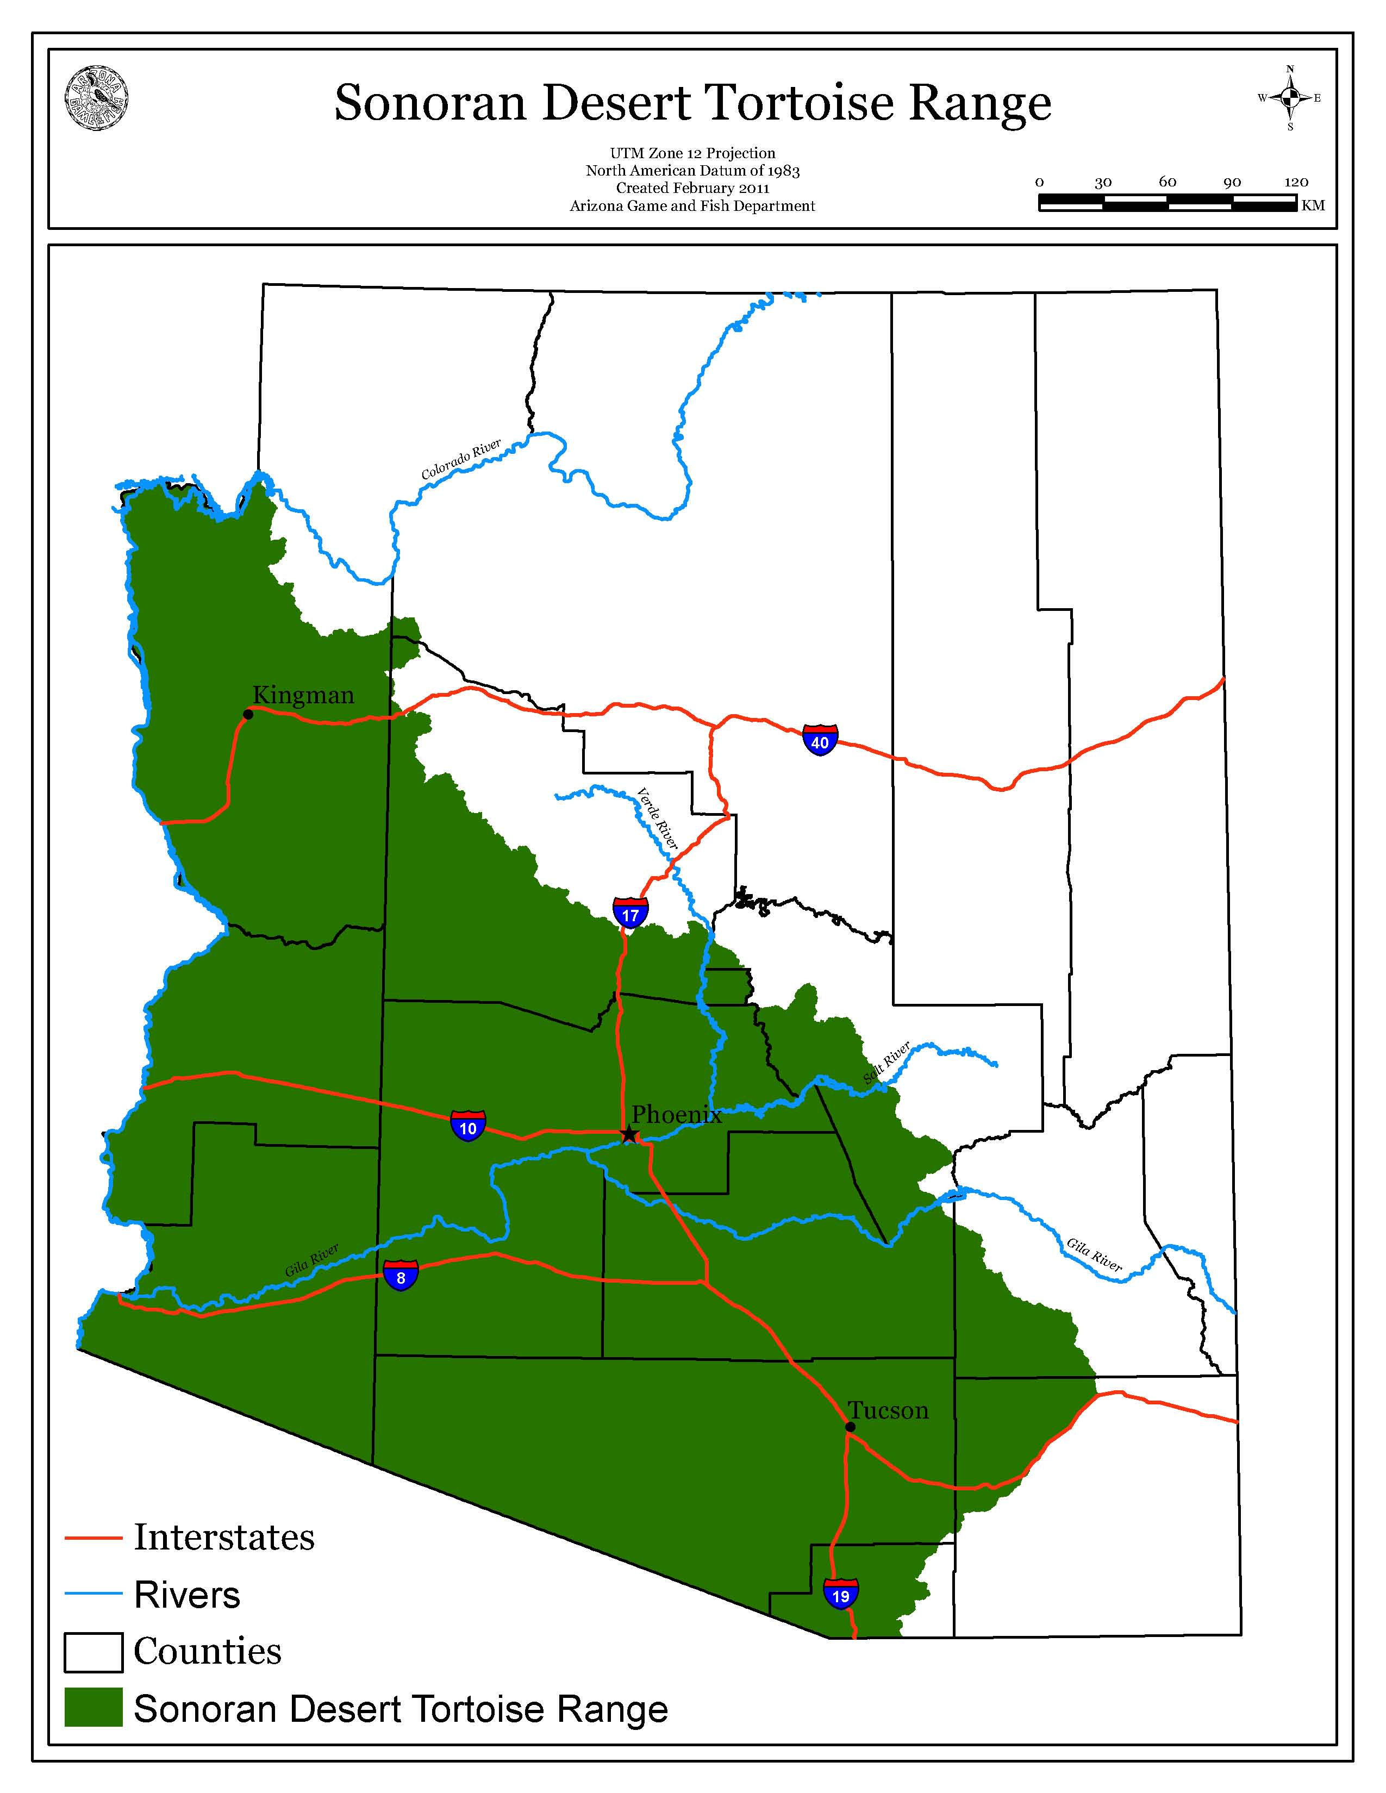
Appendix B: Photographic Examples of Tortoise Sign

SHELTERS:
Shelters are often modified from mammal burrows or natural refuges in rocky terrain, and range in depth from merely covering the carapace to over 10 meters.

Boulder/boulder pile: spaces or tunnels protected by a single or group of boulders above, with soil below.
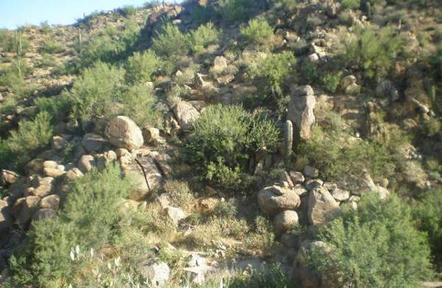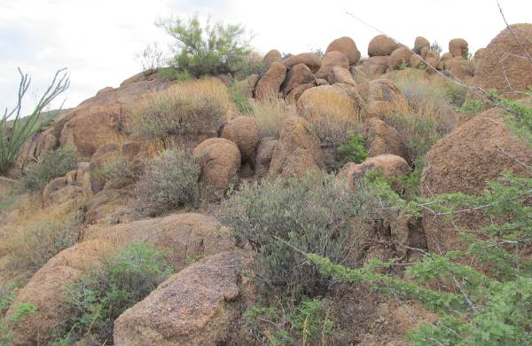
Photo: AGFD Photo: AGFD

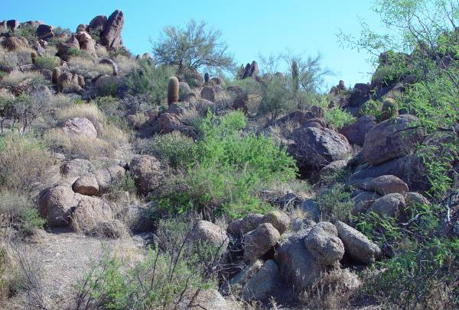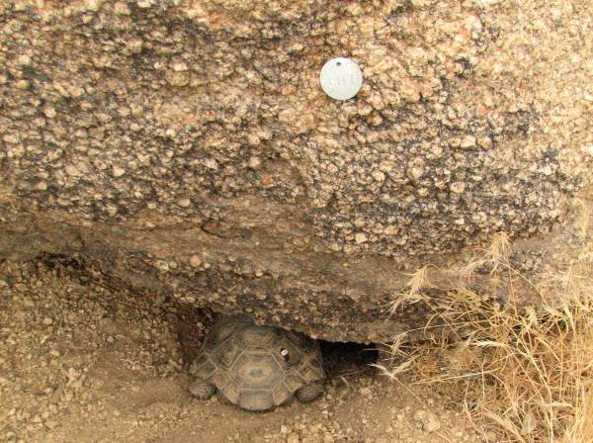
Photo: AGFD Photo: AGFD

Caliche caves: cavities eroded or excavated into hard calcium carbonate soils along incised arroyo (dry stream) banks.
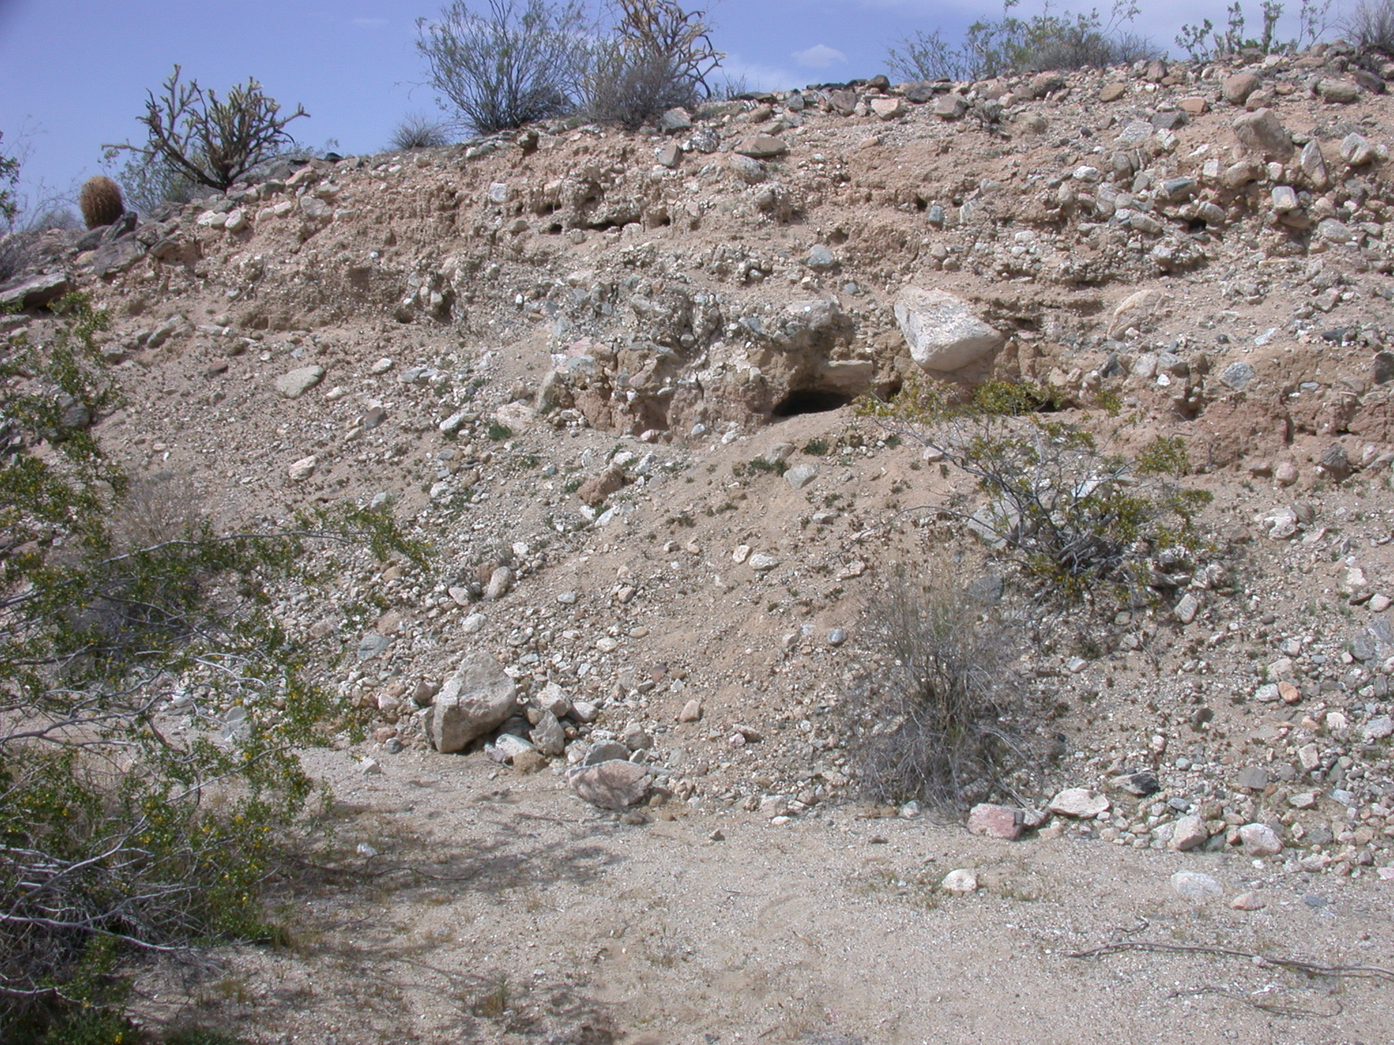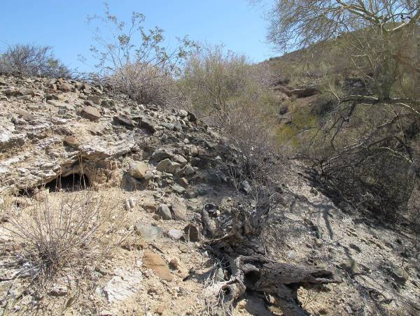
Photo: AGFD Photo: B. K. Sullivan

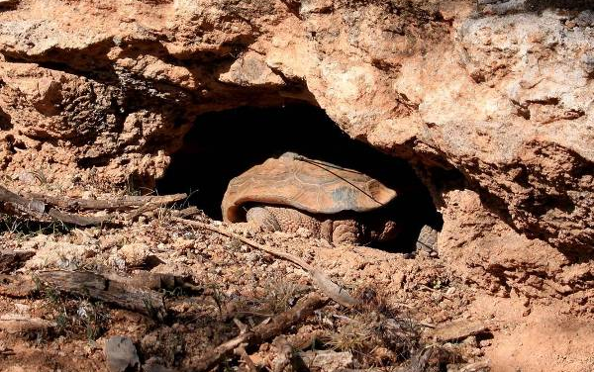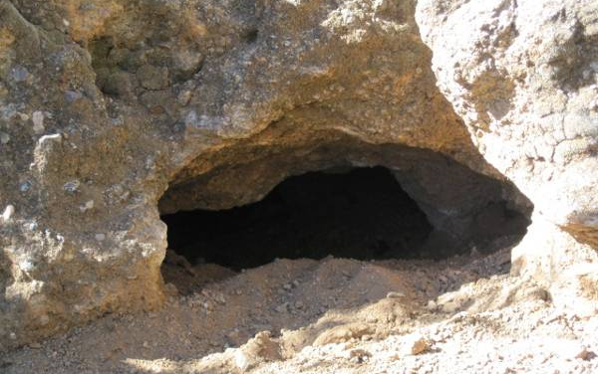
Photo: B.K. Sullivan Photo: AGFD

Incised washes:
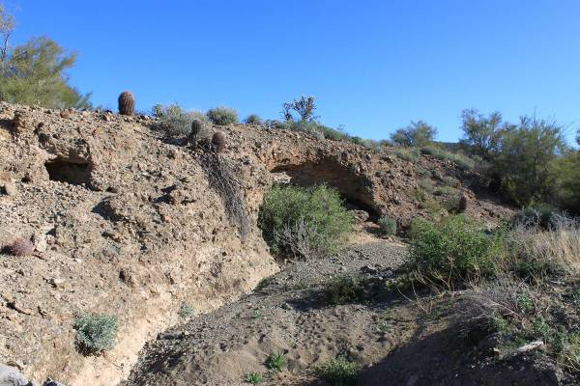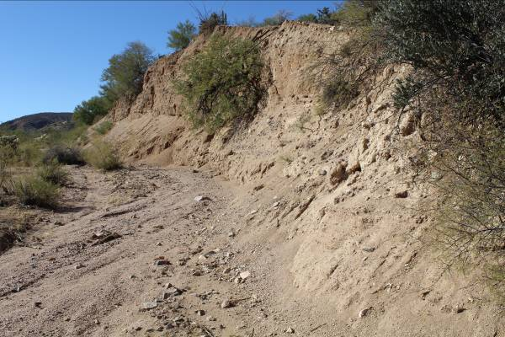
Photo: B. K. Sullivan Photo: W. W. Meyer

Caves/crevices: spaces or tunnels protected by rocks and/or boulders both above and below.
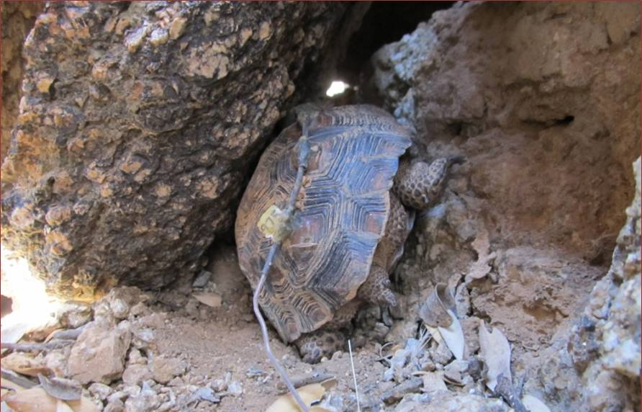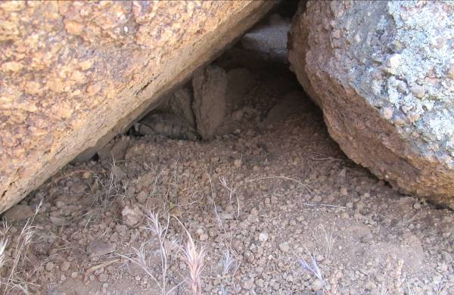
Photo: AGFD Photo: AGFD

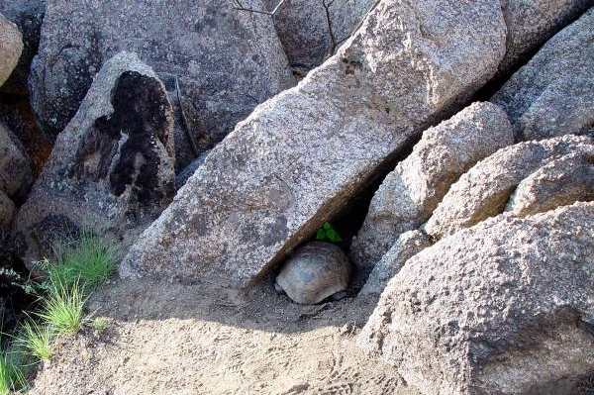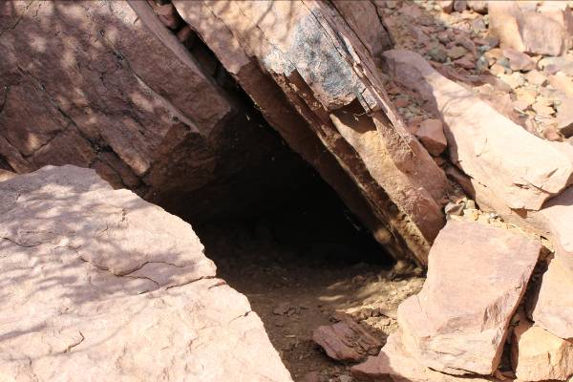
Photo: AGFD Photo: W. W. Meyer

Midden: constructed of woody debris and pieces of cacti, primarily cholla; may be in a pile, or more typically at the entrance of a caliche cave.

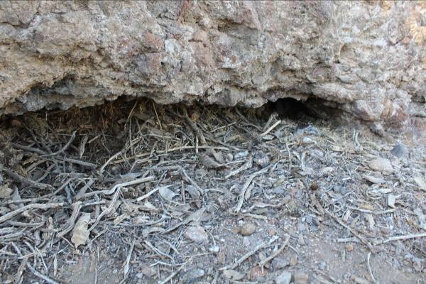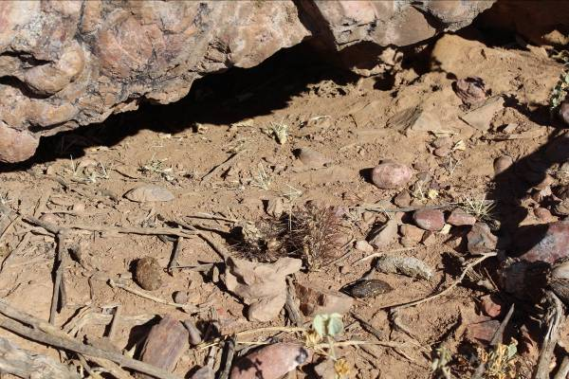
Photo: W. W. Meyer Photo: W. W. Meyer

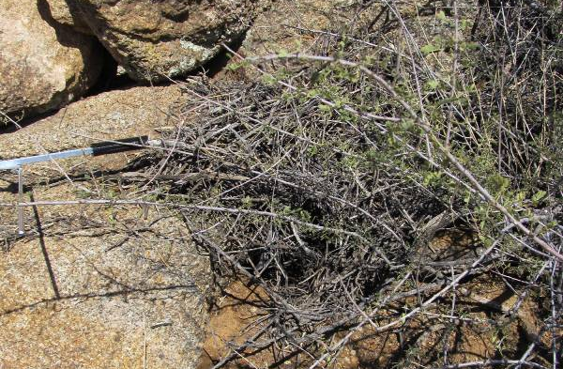
Photo: AGFD

Pallet: shallow depression in the soil, often, but not always, under low shrubs.

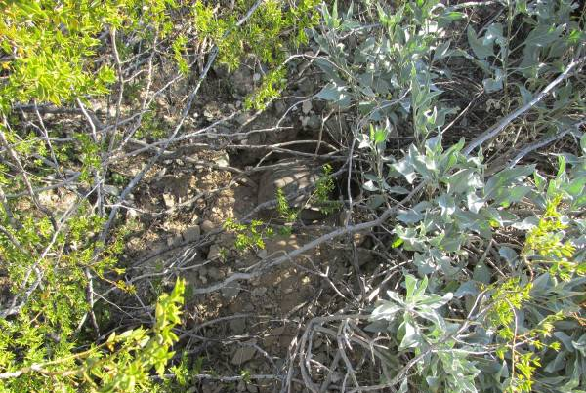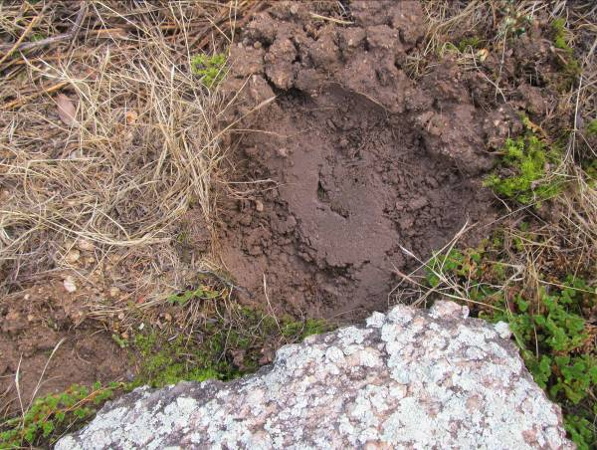
Photo: B. K. Sullivan Photo: AGFD

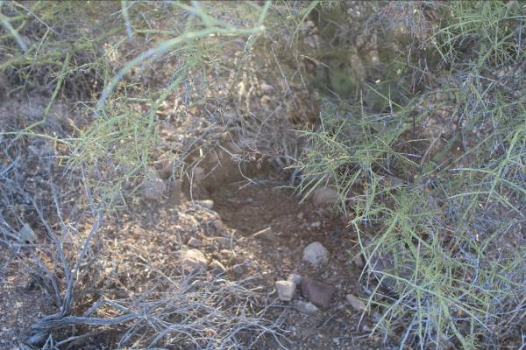
Photo: W. W. Meyer

Rock overhang: spaces or tunnels protected by rocks above, with soil below.
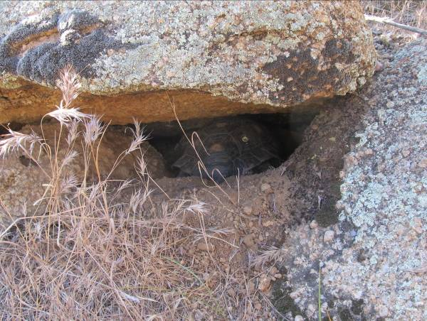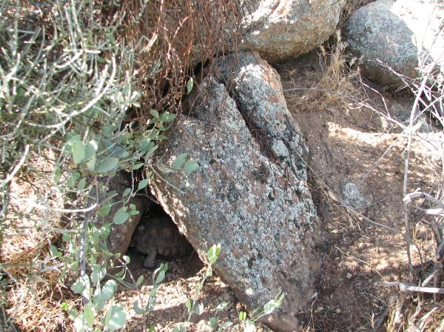
Photo: AGFD Photo: AGFD

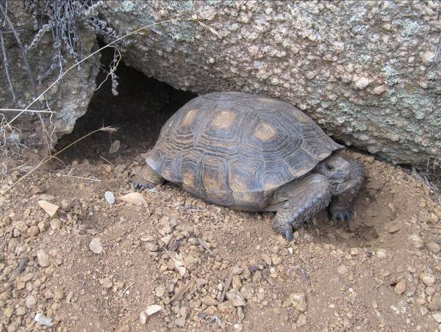
Photo: AGFD

Shelter clusters:
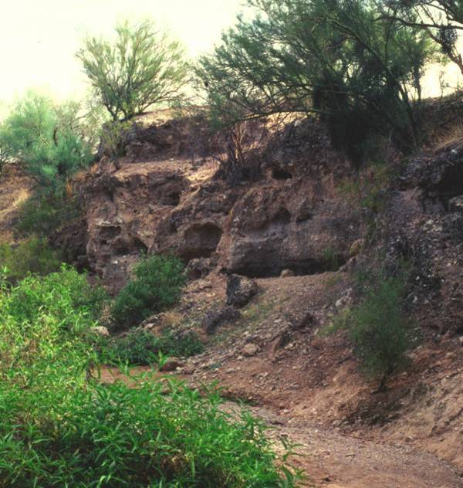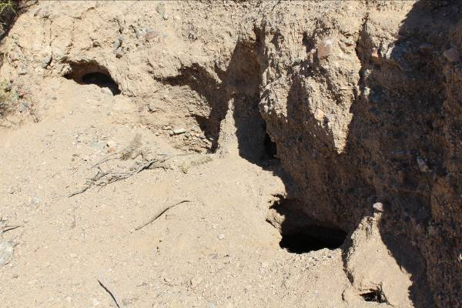
Photo: AGFD Photo: K. E. Kline

Soil burrows: distinctly crescent shaped hole with soil above and soil below, can be found in flats and or along stretches with more gently sloping sides.
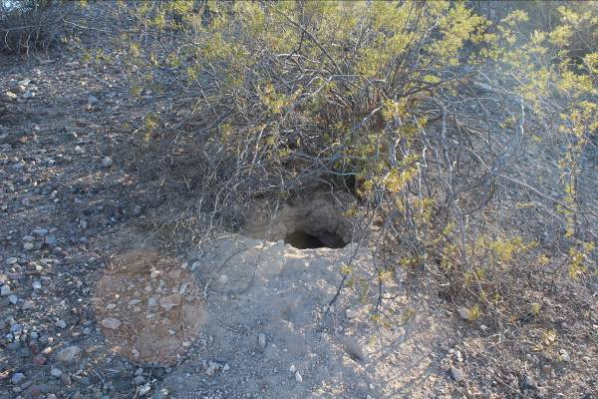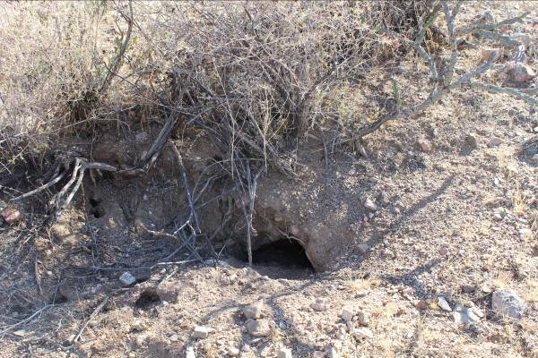
Photo: W. W. Meyer Photo: W. W. Meyer

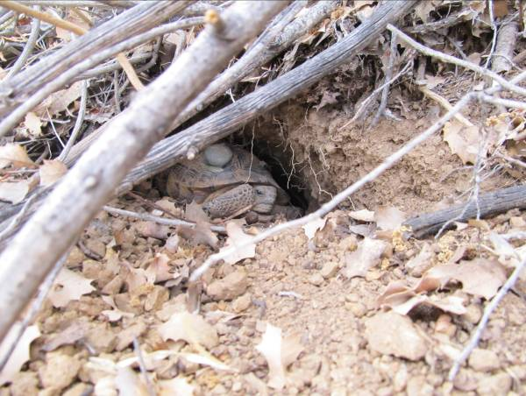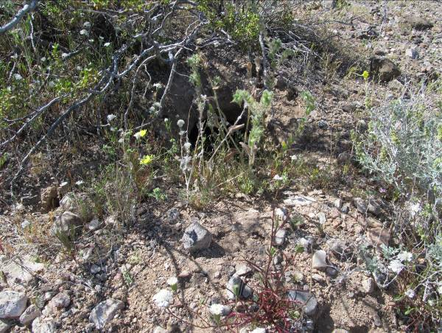
Photo: AGFD Photo: AGFD

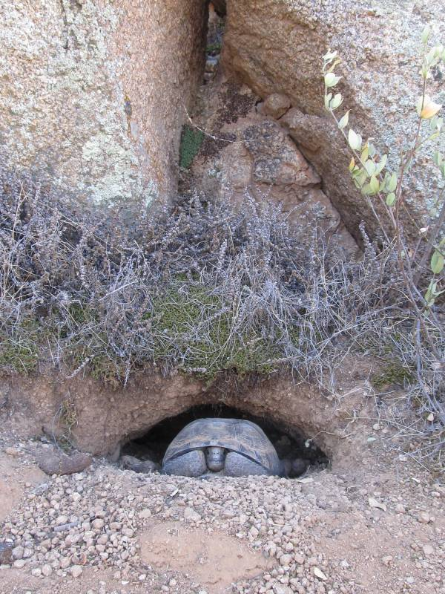
Photo: AGFD

Vegetation (live or dead):

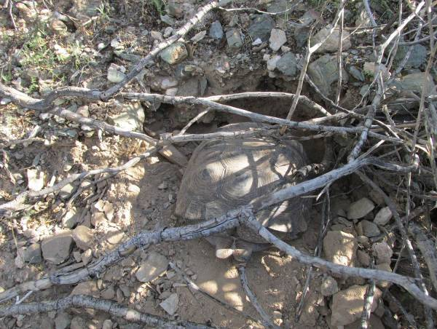
Photo: B. K. Sullivan

NESTING SITES:
Nesting sites are typically at the entrance of a shelter or under a shrub, sometimes indicated by a berm or apron; eggs are laid in nests dug 3-10 inches deep in soil.
Eggshell fragments
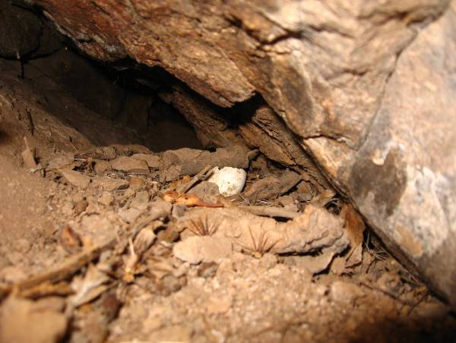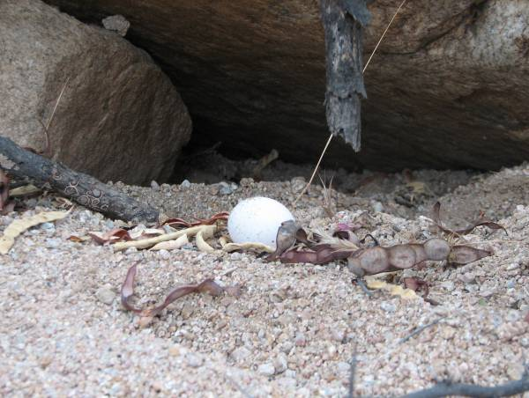
Photo: AGFD Photo: AGFD

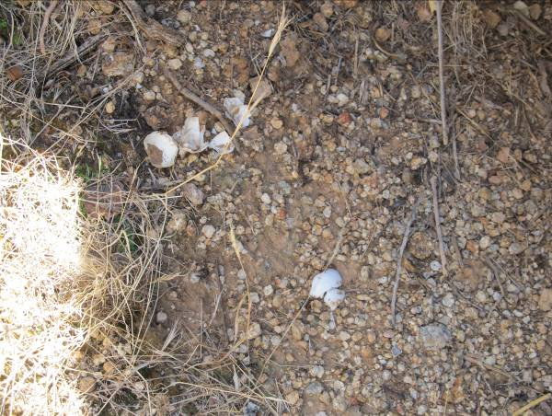
Photo: AGFD

MINERAL MINE:

Mineral mines are areas excavated by scraping away the top soil to reach subsurface calcium-rich deposits in the underlying caliche (calcium carbonate); SDT seek out and consume these deposits for mineral supplementation. Some mines are persistently utilized.

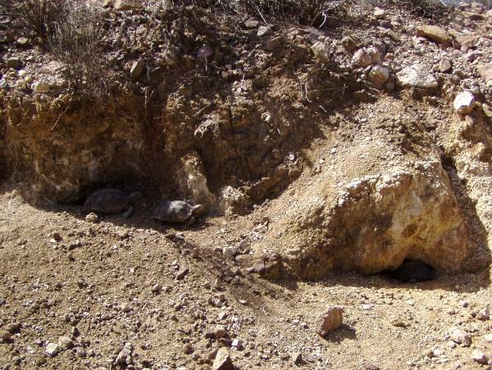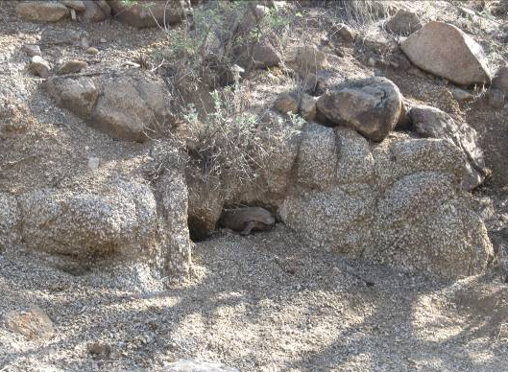
Photo: C. A. Jones Photo: AGFD

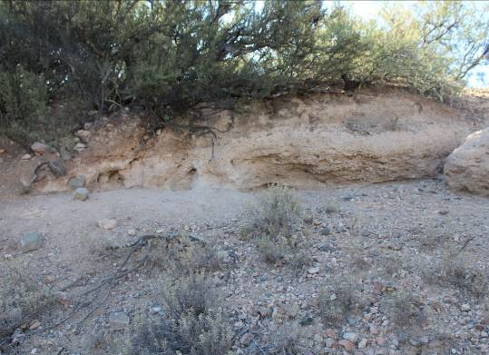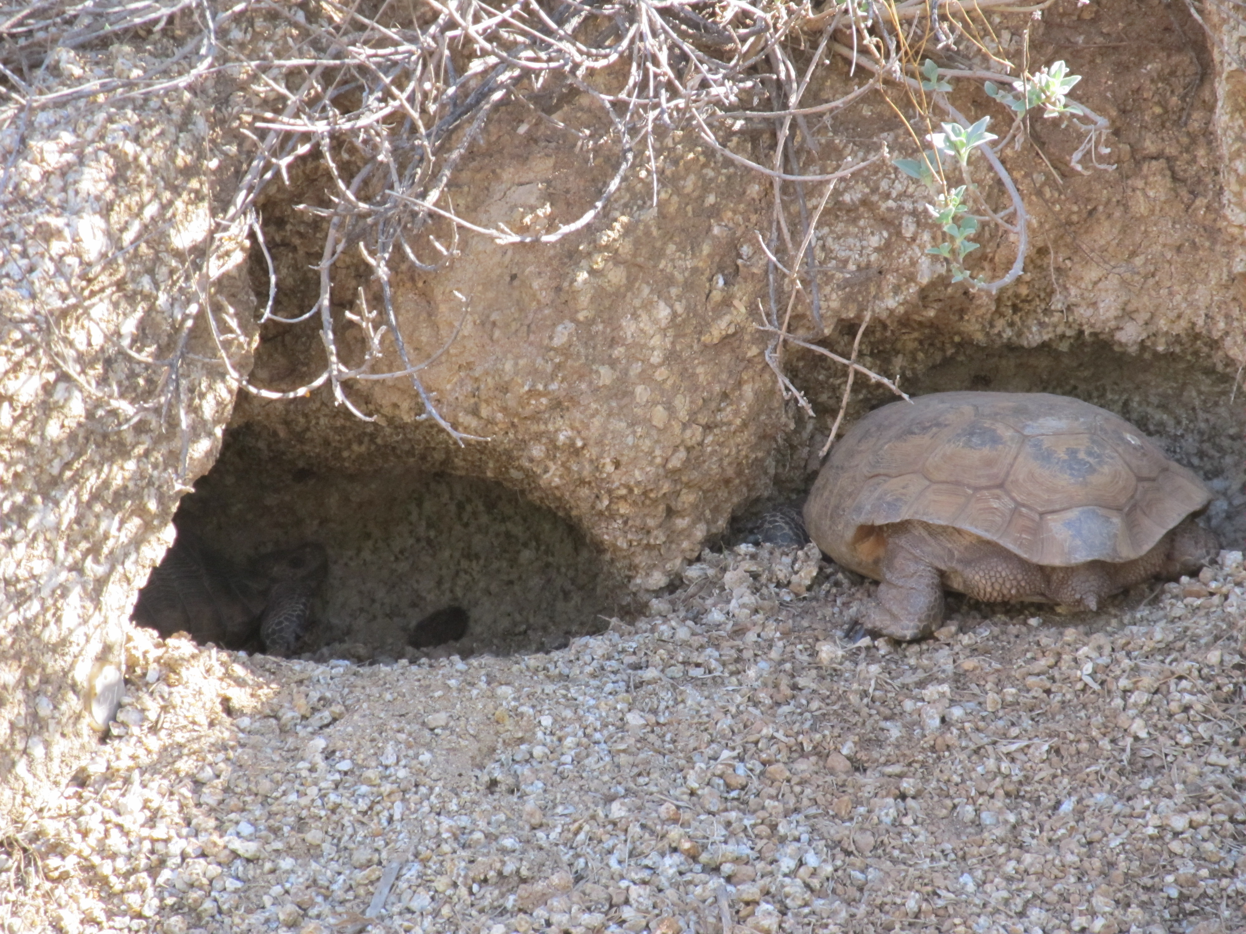
Photo: W. W. Meyer Photo: AGFD

SCAT:

Fecal dropping; fibrous, firm, and brownish-green in color with coarse plant material readily recognizable; typically with one rounded and one tapered end. The tapered end usually indicates the direction the tortoise was traveling.

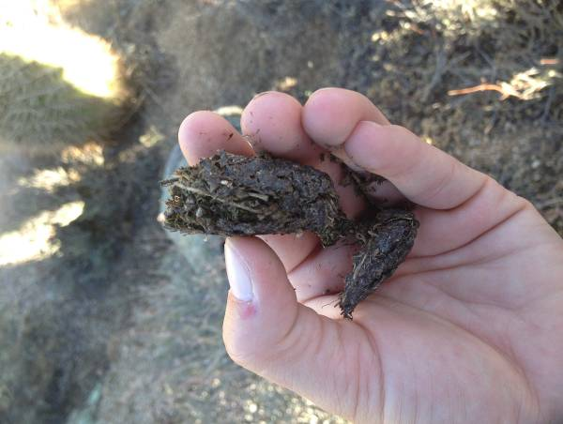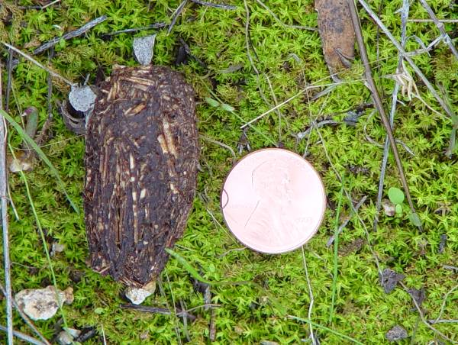
Photo: AGFD Photo: AGFD

Fresh: dark brown or black and slightly moist
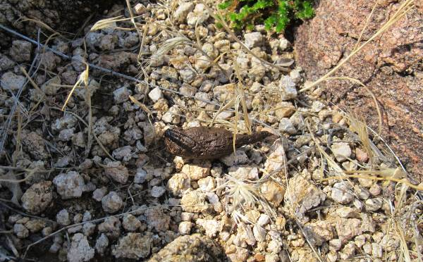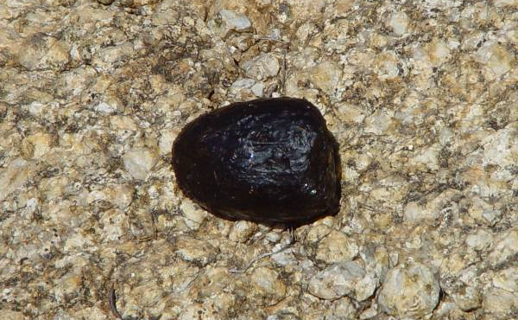
Photo: AGFD Photo: AGFD

Dry:
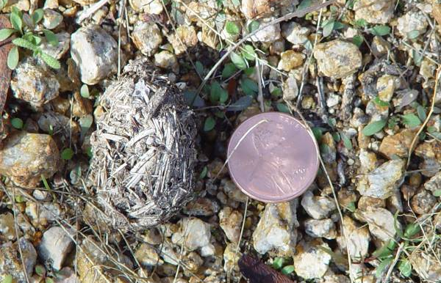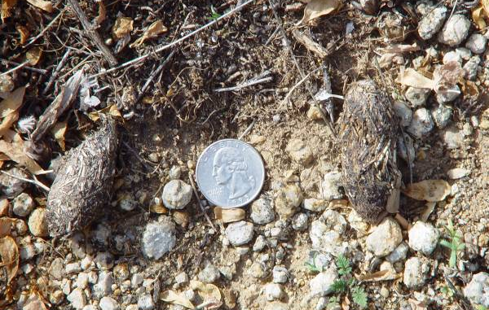
Photo: AGFD Photo: AGFD

Mud scat: result of damp soil consumption during the summer monsoon season.
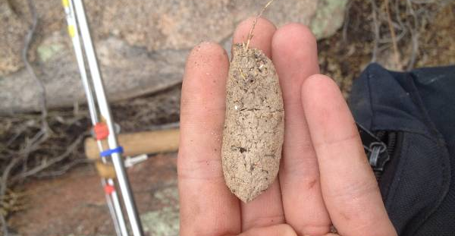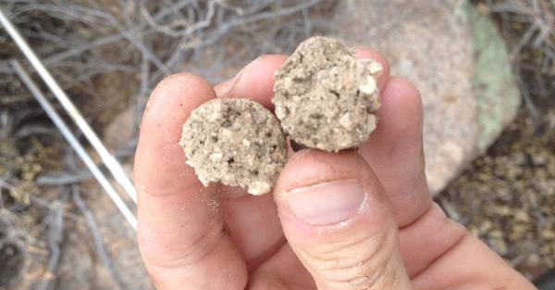
Photo: AGFD Photo: AGFD

Size range:
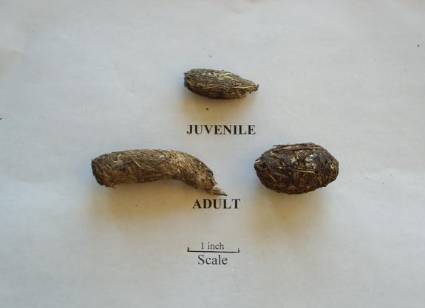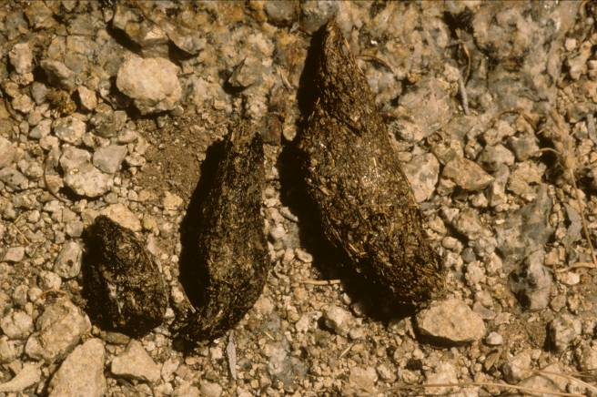
Photo: W. W. Meyer Photo: W. W. Meyer
TRACKS:
Desert tortoise tracks are best seen in soft or sandy soil, and appear as parallel rows of rounded dents, similar to tank or bulldozer tracks, with the direction of travel indicated by the sand or soil heaped up at the rear of each mark. Multiple sets of tracks in a non-linear path may indicate breeding activity or male to male combat.

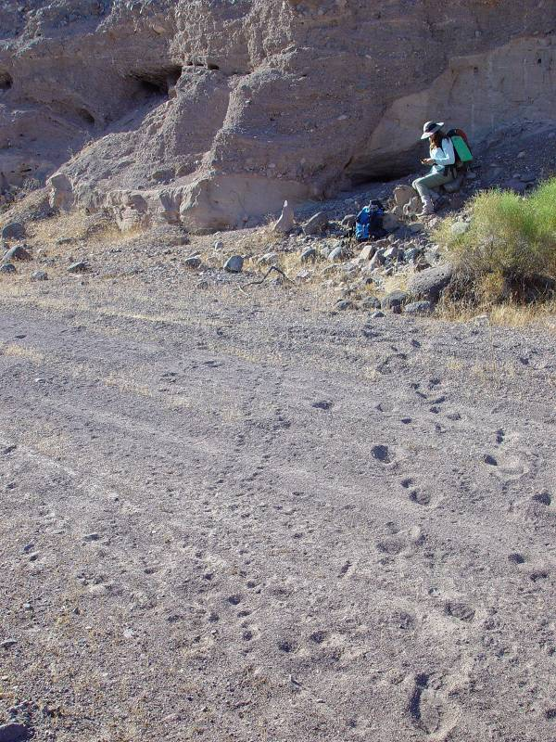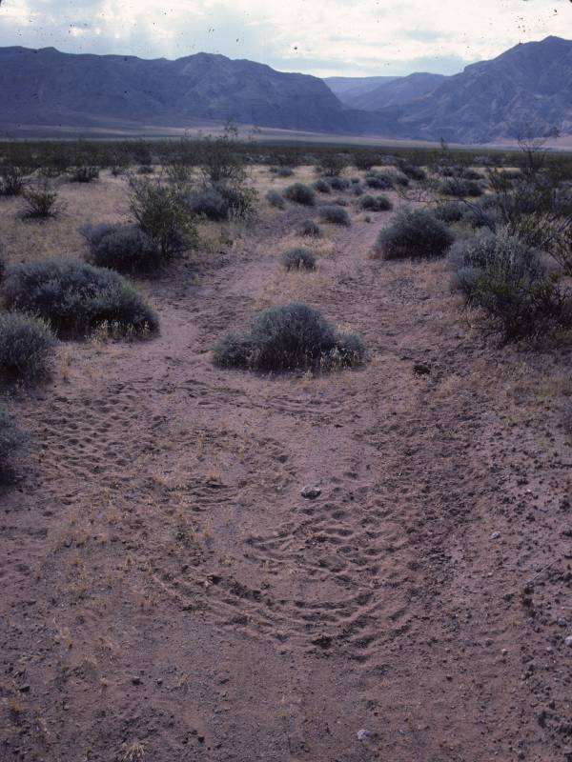
Photo: J. D. Riedle Photo: AGFD

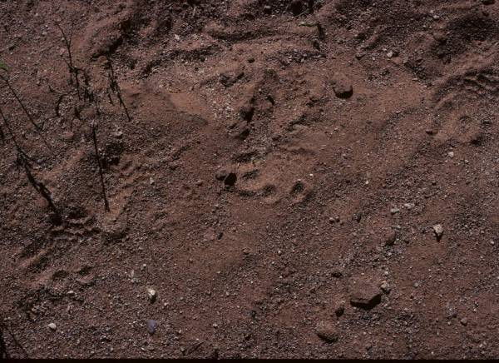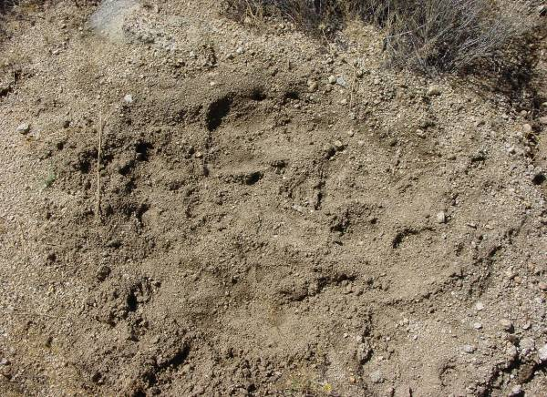
Photo: AGFD Photo: AGFD

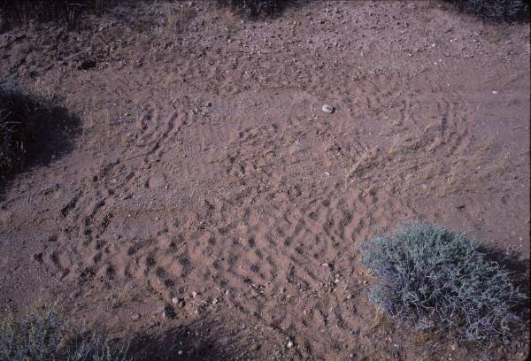
Photo: AGFD

CARCASS:
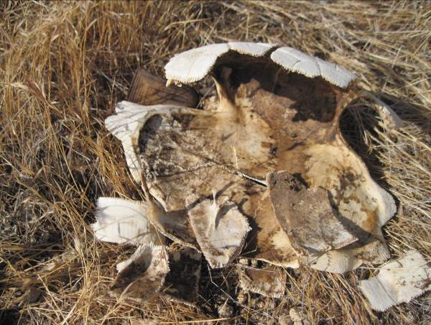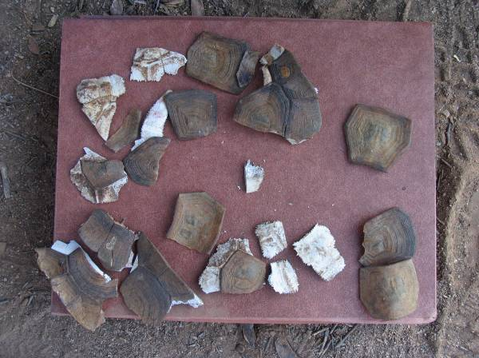
Photo: AGFD Photo: AGFD

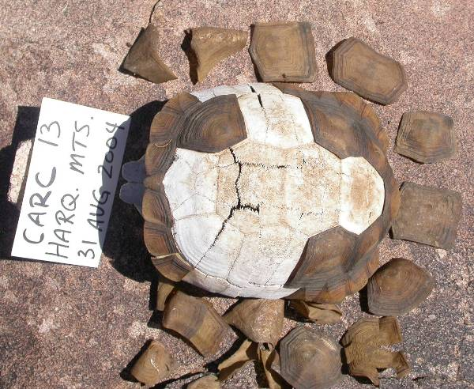
Photo: AGFD

Appendix C: Guidelines for Handling Sonoran Desert Tortoises Encountered on Development Projects. Arizona Game and Fish Department. Revised October 23, 2007. http://www.azgfd.gov/hgis/pdfs/Tortoisehandlingguidelines.pdf

The Arizona Game and Fish Department (Department) has developed the following guidelines to reduce potential impacts to desert tortoises, and to promote the continued existence of tortoises throughout the state. These guidelines apply to short-term and/or small-scale projects, depending on the number of affected tortoises and specific type of project.

Tortoises encountered in the open should be moved out of harm's way to adjacent appropriate habitat. If an occupied burrow is determined to be in jeopardy of destruction, the tortoise should be relocated to the nearest appropriate alternate burrow or other appropriate shelter, as determined by a qualified biologist. Tortoises should be moved less than 48 hours in advance of the habitat disturbance so they do not return to the area in the interim. Tortoises should be moved quickly, kept in an upright position parallel to the ground at all times, and placed in the shade. Separate disposable gloves should be worn for each tortoise handled to avoid potential transfer of disease between tortoises. Tortoises must not be moved if the ambient air temperature exceeds 40° Celsius (105° Fahrenheit) unless an alternate burrow is available or the tortoise is in imminent danger.

A tortoise may be moved up to one-half mile, but no further than necessary from its original location. If a release site, or alternate burrow, is unavailable within this distance, and ambient air temperature exceeds 40° Celsius (105° Fahrenheit), the Department should be contacted to place the tortoise into a Department-regulated, desert tortoise adoption program. Tortoises salvaged from projects which result in substantial permanent habitat loss, or those requiring removal during long-term (longer than one week) construction projects, will also be placed in desert tortoise adoption programs.

Managers of projects likely to affect desert tortoises should obtain a scientific collecting permit from the Department to facilitate temporary possession of tortoises. Likewise, if large numbers of tortoises (>5) are expected to be displaced by a project, the project manager should contact the Department for guidance and/or assistance.

Please keep in mind the following points:
- These guidelines do not apply to the Mojave population of desert tortoises (north and west of the Colorado River). Mohave desert tortoises are specifically protected under the Endangered Species Act, as administered by the U.S. Fish and Wildlife Service.
- These guidelines are subject to revision at the discretion of the Department. We recommend that the Department be contacted during the planning stages of any project that may affect desert tortoises.
- Take, possession, or harassment of wild desert tortoises is prohibited by state law. Unless specifically authorized by the Department, or as noted above, project personnel should avoid disturbing any tortoise.
Appendix D: Resource Concerns on Rangeland addressed with Conservation Practices by the Natural Resources Conservation Service.

category | Resource Concern | Description of Concern
SOIL EROSION | SOIL EROSION:  Sheet, rill, & wind erosion | Detachment and transportation of soil particles caused by rainfall runoff / splash, irrigation runoff, or wind that degrades soil quality.
SOIL EROSION | SOIL EROSION: Concentrated flow erosion | Untreated classic gullies may enlarge progressively by head cutting and/or lateral widening. Ephemeral gullies occur in the same flow area and are obscured by tillage. This includes concentrated flow erosion caused by runoff from rainfall, snowmelt, or irrigation water.
SOIL EROSION | SOIL EROSION: Excessive bank erosion from streams, shorelines, or water conveyance channels | Sediment from banks or shorelines threatens to degrade water quality and limit use for intended purposes.
EXCESS /  INSUFFICENT  WATER | EXCESS WATER: Ponding, flooding, seasonal high water table, seeps, and drifted snow | Surface water or poor subsurface drainage restricts land use and management goals. Wind-blown snow accumulates around and over surface structures, restricting access to humans and animals.
EXCESS /  INSUFFICENT  WATER | INSUFFICIENT WATER: Inefficient moisture management | Natural precipitation is not optimally managed to support desired land use goals or ecological processes.
WATER QUALITY  DEGRADATION | WATER QUALITY DEGRADATION: Pesticides transported to surface and ground waters | Pesticides are transported to receiving waters in quantities that degrade water quality and limit use for intended purposes.
WATER QUALITY  DEGRADATION | WATER QUALITY DEGRADATION:  Excess pathogens and chemicals from manure, bio-solids or compost applications | Pathogens, pharmaceuticals, and other chemicals are transported to receiving waters in quantities that degrade water quality and limit use for intended purposes. This resource concern also includes the off-site transport of leachate and runoff from silage, compost, or other organic materials.
WATER QUALITY  DEGRADATION | WATER QUALITY DEGRADATION: Petroleum, heavy metals, and other pollutants transported to receiving water sources | Heavy metals, petroleum, and other pollutants are transported to receiving water sources in quantities that degrade water quality and limit use for intended purposes.
DEGRADED PLANT  CONDITION | DEGRADED PLANT CONDITION:  Undesirable plant productivity and health | Plant productivity, vigor, and/or quality do not negatively affect other resources or meet yield potential due to improper fertility, management, or plants not adapted to site.  This concern addresses pollinators, beneficial insects, wind erosion, and excess soil deposition that influence plant condition.
DEGRADED PLANT  CONDITION | DEGRADED PLANT CONDITION:  Inadequate structure and composition | Plant communities have insufficient composition and structure to achieve ecological functions and management objectives.  This concern addresses loss or degradation of wetland habitat, targeted ecosystems, or unique plant communities.
DEGRADED PLANT  CONDITION | DEGRADED PLANT CONDITION:  Excessive plant pest pressure | Excessive pest damage to plants including that from undesired plants, diseases, animals, soil borne pathogens, and nematodes.  This concern addresses invasive plant, animal, and insect species.
DEGRADED PLANT  CONDITION | DEGRADED PLANT CONDITION:  Wildfire hazard, excessive biomass accumulation | The kinds and amounts of fuel loadings (plant biomass) create wildfire hazards that pose risks to human safety, structures, plants, animals, and air resources.
INADEQUATE HABITAT  FOR FISH AND WILDLIFE | INADEQUATE HABITAT FOR FISH AND WILDLIFE:  Habitat degradation | Quantity, quality, or connectivity of food, cover, space, shelter, and/or water is inadequate to meet requirements of identified fish, wildlife, and invertebrate species.

APPENDIX E. Desert Tortoise Survey Guidelines for Environmental Consultants. Arizona Game and Fish Department. Revised June 2010.
http://www.azgfd.gov/hgis/documents/2010SurveyGuidelinesForConsultants.pdf.

The following informal guidelines are intended to aid private consultants surveying for presence of tortoises on development projects in the Sonoran Desert. Following these guidelines will not provide quantified abundance estimates.

  - Surveys will be most productive during tortoise activity periods, primarily during the summer monsoon season (July – September) but also in the spring (April) and fall (October). Tortoises are most active in the morning and evening during summer, late morning to afternoon in spring and fall. Results from summer/fall monitoring plots indicate that tortoises are active at temperatures from 20 to 45°C (1cm above ground).

  - In the Sonoran Desert, tortoises usually occur on rocky slopes in desertscrub to semidesert grassland, as well as along washes, and extending into creosotebush flats. Burrows typically occur below rocks and boulders and may be irregularly shaped. Soil burrows and those in wash banks may have a 1/2-moon appearance.

  - Presence-absence surveys (3 hectare plots) or clearance surveys (100% coverage), depending on project type, are recommended to survey a discrete parcel of land. The number of 3-hectare plots per unit area depends on the desired intensity of the survey.

  - Surveyors should record all live tortoises, carcasses, scat, verified burrows (with scat or tortoise inside), and otherwise suitable/potential burrows (empty) and report to the Department.

  - Refer to the Department’s “Guidelines for Handling Sonoran Desert Tortoises Encountered on Development Projects” if handling will be necessary – available at: http://www.azgfd.gov/ hgis/pdfs/Tortoisehandlingguidelines.pdf.

Appendix F. List Of Locally Adapted, Important Forage And Cover Plants For Sonoran Desert Tortoises. Not all species are appropriate for all situations, and use of these plants will depend on the characteristics of the local landscape.

Common Name | Scientific Name | Benefit
Grasses
Six-weeks three-awn | Aristida adscensionis | Medium PEP
Grama grass | Bouteloua sp. | Medium PEP
Fluffgrass | Erioneuron pulchellum | Medium PEP
Big galleta grass | Pleuraphis rigida | Medium (8.0) PEP/Cover
Bush muhly | Muhlenbergia porteri | Cover
Indian rice grass | Oryzopsis hymenoides | Cover
Sand dropseed | Sporobolis cryptandrus | Cover
Desert needle grass | Stipa speciosa | Cover
Six-weeks fescue | Vulpia octoflora | Cover
Shrubs
White bursage | Ambrosia dumosa | Cover
Eastern mojave buckwheat | Eriogonum fasciculatum | Cover
Mormon tea | Ephedra viridis | Cover
Spiny hopsage | Grayia spinosa | Cover
Little-leaf ratany | Krameria erecta | Cover
Creosote bush | Larrea tridentata | Cover
Forbs
Trailing windmills | Allionia incarnate | Cover
Dwarf white milkvetch | Astragalus didymocarpus | High PEP
Widow’s milkfetch | Astragalus layneae | High PEP
Brown-eyed primrose | Camissonia claviformis | High PEP
Desert pincushion | Chaenactis fremontii
Cryptantha | Cryptantha spp. | Cover
Whitemargin sandmat | Euphorbia albomarginata | Medium PEP
Sonoran sandmat | Euphorbia micromera | High PEP
Strigose bird’s-foot trefoil | Lotus strigosus | High PEP
Smooth desertdandelion | Malacothrix glabrata | High PEP
Curvenut combseed | Pectocarya recurvata | Cover
Plantain | Plantago spp. | M-H PEP 14-15
Desert globemallow | Sphaeralcea ambigua | Medium PEP
Cleftleaf wildheliotrope | Phacelia crenulata | Medium PEP
Desert evening primrose | Oenothera primiveris
Schott’s calico | Loeseliastrum schottii | High PEP

APPENDIX G. Invasive Nonnative Plants That Threaten Wildlands in Arizona. These species should never be planted in Arizona. For more information, please visit: http://www.swvma.org/invasivenonnativeplantsthatthreatenwildlandsinarizona.html, or review Northam et al. 2005.

Common Name | Scientific Name
Russian knapweed | Acroptilon repens
Jointed goatgrass | Aegilops cylindrica
Camelthorn | Alhagi maurorum
Giant reed | Arundo donax
Onionweed | Asphodelus fistulosus
Wild Oat | Avena fatua
Sahara mustard | Brassica tournefortii
Ripgut brome | Bromus diandrus
Smooth brome | Bromus inermis
Red brome | Bromus rubens
Cheatgrass | Bromus tectorum
Lenspod whitetop | Cardaria chalapensis
Whitetop | Cardaria draba
Hairy whitetop | Cardaria pubescens
Musk thistle | Carduus nutans
Spotted knapweed | Centaurea biebersteinii
Diffuse knapweed | Centaurea diffusa
Malta starthistle | Centaurea melitensis
Yellow starthistle | Centaurea solstitialis
Rush skeletonweed | Chondrilla juncea.
Canada thistle | Cirsium arvense
Bull thistle | Cirsium vulgare
Poison hemlock | Conium maculatum
Field bindweed | Convolvulus arvensis
Pampass grass | Cortaderia selloana
Bermudagrass | Cynodon dactylon.
Houndstongue | Cynoglossum officinale
Barnyardgrass | Echinochloa crus-galli
Water hyacinth | Eichhornia crassipes
Russian olive | Elaeagnus angustifolia
Quackgrass | Elymus repens
Weeping lovegrass | Eragrostis curvula
Lehmann lovegrass | Eragrostis lehmanniana
Redstem filaree | Erodium cicutarium
Leafy spurge | Euphorbia esula
Sweet resinbush | Euryops multifidus
Mouse barley | Hordeum murinum
Hydrilla | Hydrilla verticillata
Perennial pepperweed | Lepidium latifolium
Oxeye daisy | Leucanthemum vulgare
Dalmation toadflax | Linaria dalmatica
Yellow toadflax | Linaria vulgaris
Perennial ryegrass | Lolium perenne
White sweetclover | Melilotus alba
Yellow sweetclover | Melilotus officinalis
Common iceplant | Mesembryanthemum crystallinum
Slenderleaf iceplant | Mesembryanthemum nodiflorum
Parrot's feather | Myriophyllum aquaticum
Eurasian watermilfoil | Myriophyllum spicatum
Scotch thistle | Onopordum acanthium
Blue panicum | Panicum antidotale
Buffelgrass | Pennisetum ciliare
Fountain grass | Pennisetum setaceum
African sumac | Rhus lancea
Himalayan blackberry | Rubus armeniacus
Ravengrass | Saccharum ravennae
Russian thistle | Salsola collina
Barbwire Russian thistle | Salsola paulsenii
Prickly Russian thistle | Salsola tragus
Giant salvinia | Salvina molesta
Arabian schismus | Schismus arabicus
Common Mediterranean grass | Schismus barbatus
Spiny sowthistle | Sonchus asper
Annual sowthistle | Sonchus oleraceus
Johnsongrass | Sorghum halepense
Athel tamarisk | Tamarix aphylla
Five stamen tamarisk | Tamarix chinensis
Small flower tamarisk | Tamarix parviflora
Saltcedar | Tamarix ramosissima
Puncturevine | Tribulus terrestris
Siberian elm | Ulmus pumila
Common mullein | Verbascum thapsus
Bigleaf periwinkle | Vinca major

APPENDIX H. Recommended Specifications for Desert Tortoise Exclusion Fencing. U.S. Fish and Wildlife Service. Revised September 2005. http://www.fws.gov/nevada /desert_tortoise/documents/field_manual/CHAPTER-8.pdf.

These specifications were developed to standardize fence materials and construction procedures to confine tortoises or exclude them from harmful situations, primarily roads and highways. Prior to commencing any field work, all field workers should comply with all stipulations and measures developed by the jurisdictional land manager and the U.S. Fish and Wildlife Service for conducting such activities in desert tortoise habitat, which will include, at a minimum, completing a desert tortoise education program.

Fence Construction Materials
Fences should be constructed with durable materials (i.e., 16 gauge or heavier) suitable to resist desert environments, alkaline and acidic soils, wind, and erosion. Fence material should consist of 1-inch horizontal by 2-inch vertical, galvanized welded wire, 36 inches in width. Other materials include: Hog rings, steel T-posts, and smooth or barbed livestock wire. Hog rings should be used to attach the fence material to existing strand fence. Steel T-posts (5 to 6-foot) are used for new fence construction. If fence is constructed within the range of bighorn sheep, 6-foot
T-posts should be used (see New Fence Construction below). Standard smooth livestock wire fencing should be used for new fence construction, on which tortoise-proof fencing would be attached.

Retrofitting Existing Livestock Fence
Option 1 (see drawing). Fence material should be buried a minimum of 12 inches below the ground surface, leaving 22-24 inches above ground. A trench should be dug or a cut made with a blade on heavy equipment to allow 12 inches of fence to be buried below the natural level of the ground. The top end of the tortoise fence should be secured to the livestock wire with hog rings at 12 to 18-inch intervals. Distances between T-posts should not exceed 10 feet, unless the tortoise fence is being attached to an existing right-of-way fence that has larger interspaces between posts. The fence must be perpendicular to the ground surface, or slightly angled away from the road, towards the side encountered by tortoises. After the fence has been installed and secured to the top wire and T-posts, excavated soil will be replaced and compacted to minimize soil erosion.

Option 2 (see drawing). In situations where burying the fence is not practical because of rocky or undigable substrate, the fence material should be bent at a 90⁰ angle to produce a lower section approximately 14 inches wide which will be placed parallel to, and in direct contact with, the ground surface; the remaining 22-inch wide upper section should be placed vertically against the existing fence, perpendicular to the ground and attached to the existing fence with hog rings at 12 to18-inch intervals. The lower section in contact with the ground should be placed within the enclosure in the direction of potential tortoise encounters and level with the ground surface. Soil and cobble (approximately 2 to 4 inches in diameter; can use larger rocks where soil is shallow) should be placed on top of the lower section of fence material on the ground covering it with up to 4 inches of material, leaving a minimum of 18 inches of open space between the cobble surface and the top of the tortoise-proof fence. Care should be taken to ensure that the fence material parallel to the ground surface is adequately covered and is flush with the ground surface.

New Fence Construction
Options 1 or 2 should be followed except in areas that require special construction and engineering such as wash-out sections (see below). T-posts should be driven approximately 24 inches below the ground surface spaced approximately 10 feet apart. Livestock wire should be stretched between the T-posts, 18 to 24 inches above the ground to match the top edge of the fence material; desert tortoise-proof fencing should be attached to this wire with hog rings placed at 12 to 18-inch intervals. Smooth (barb-less) livestock wire should be used except where grazing occurs.

If fence is constructed within the range of bighorn sheep, two smooth-strand wires are required at the top of the T-post, approximately 4 inches apart, to make the wire(s) more visible to sheep. A 20 to 24-inch gap must exist between the top of the fence material and the lowest smooth-strand wire at the top of the T-post. The lower of the top two smooth-strand wires must be at least 43 inches above the ground surface.

(72-inch T-posts: 24 inches below ground + 18 inches of tortoise fence above ground + 20 to 24-inch gap to lower top wire + 4 inches to upper top wire = 66 to 70 inches).

Inspection of Desert Tortoise Barriers
The risk level for a desert tortoise encountering a breach in the fence is greatest in the spring and fall, particularly around the time of precipitation including the period during which precipitation occurs and at least several days afterward. All desert tortoise fences and cattle guards should be inspected on a regular basis sufficient to maintain an effective barrier to tortoise movement. Inspections should be documented in writing and include any observations of entrapped animals; repairs needed including bent T-posts, leaning or non-perpendicular fencing, cuts, breaks, and gaps; cattle guards without escape paths for tortoises or needed maintenance; tortoises and tortoise burrows including carcasses; and recommendations for supplies and equipment needed to complete repairs and maintenance.

All fence and cattle guard inventories should be inspected at least twice per year. However, during the first 2 to 3 years all inspections will be conducted quarterly at a minimum, to identify and document breaches, and problem areas such as wash-outs, vandalism, and cattle guards that fill-in with soil or gravel. GPS coordinates and mileages from existing highway markers should be recorded in order to pinpoint problem locations and build a database of problem locations that may require more frequent checking. Following 2 to 3 years of initial inspection, subsequent inspections should focus on known problem areas which will be inspected more frequently than twice per year. In addition to semi-annual inspections, problem areas prone to wash-outs should be inspected following precipitation that produces potentially fence-damaging water flow. A database of problem areas will be established whereby checking fences in such areas can be done efficiently.

Repair and Maintenance of Desert Tortoise Barriers
Repairs of fence wash-outs: (1) realign the fence out of the wash if possible to avoid the problem area, or (2) re-construct tortoise-proof fencing using techniques that will ensure that an effective desert tortoise barrier is established that will not require frequent repairs and maintenance. Gaps and breaks will require either: (a) repairs to the existing fence in place, with similar diameter and composition of original material, (b) replacement of the damaged section to the nearest T-post, with new fence material that original fence standards, (c) burying fence, and/or (d) restoring zero ground clearance by filling in gaps or holes under the fence and replacing cobble over fence constructed under Option 2. Tortoise-proof fencing should be constructed and maintained at cattle guards to ensure that a desert tortoise barrier exists at all times.

All fence damage should be repaired in a timely manner to ensure that tortoises do not travel through damaged sections. Similarly, cattle guards will be cleaned out of deposited material underneath them in a timely manner. In addition to periodic inspections, debris that accumulates along the fence should be removed. All cattle guards that serve as tortoise barriers should be installed and maintained to ensure that any tortoise that falls underneath has a path of escape without crossing the intended barrier.
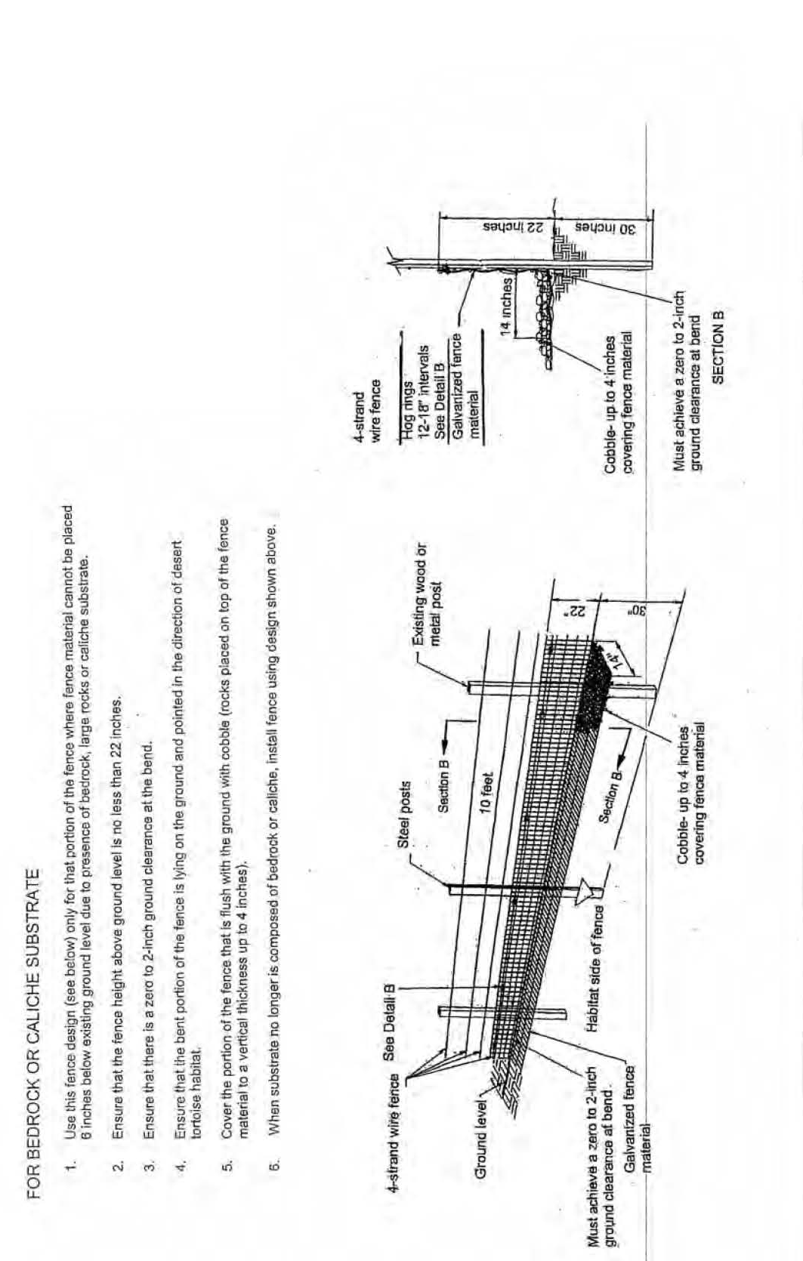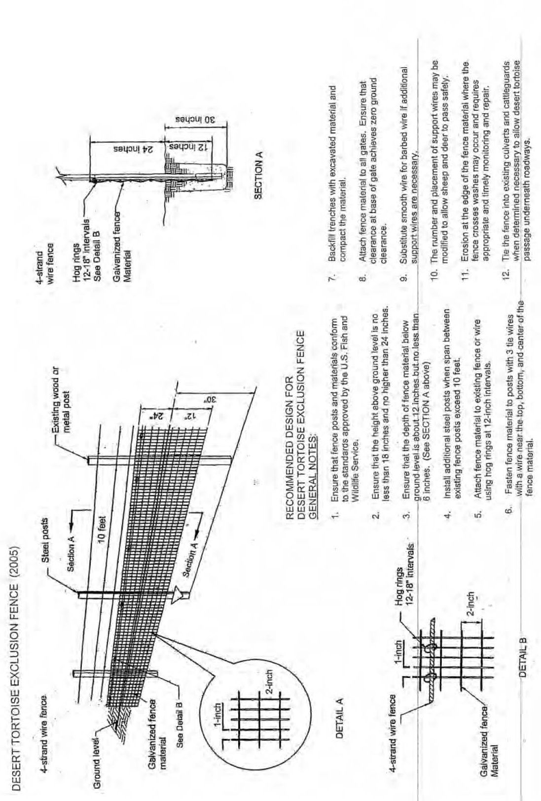
APPENDIX I: Guidelines for Temporary and Permanent Tortoise Friendly Cattle Guards. Southern Nevada Water Authority.

