The Southwest Vegetation Management Association was organized in 1997 to increase awareness about invasive vegetation and foster cooperation among vegetation managers.

Mission Statement
"To conserve and protect Arizona's natural resources by providing a state-level organization that emphasizes an integrated management approach to address invasive or pest plants."

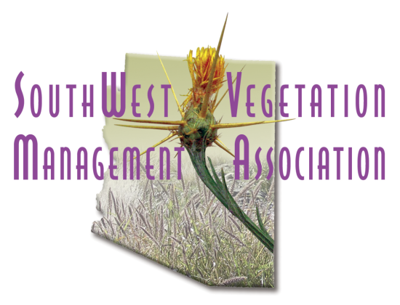
17th Annual Meeting
28-30 October 2014
Partnering in Integrated Vegetation Management

Francisco Grande Hotel
12684 Gila Bend Highway, Casa Grande, AZ

Our keynote speaker, Allen White, is the Invasive Species and Pesticide Coordinator for the Southwest Region of the Forest Service. He will kick off the meeting Tuesday with a talk about the importance of partnering. The agenda will offer talks on a variety of topics for 2 days, vendor presentations and booths, and a field trip on the third day to a location to be determined. The main theme for this year’s meeting is partnering, but there will be presentations on other topics, such as invasive mustards, a biocontrol program in northern Arizona, and an entire half-day devoted to buffelgrass topics, in cooperation with the Southern Arizona Buffelgrass Coordination Center. Agenda is posted at www.swvma.org. You can register on the same website. Tuesday evening is a happy hour mixer, where you can meet other folks interested in invasive plants, and visit with our sponsors. Lunches are included in registration; the banquet lunch on Wednesday is followed by a short all-attendee meeting where you will be updated on what the Board has been doing the past year, and election of new officers. And there will be raffle prizes!!

Consider becoming active in this organization by serving as an officer -- or you can nominate someone else who would like to be an officer on the board. Send a message to the President, John Brock with nominations or your willingness to serve as an officer for a 2-year term. (john.brock@asu.edu) Available positions are Board member, President, Vice President and Secretary.

CEU’s will be provided for Tuesday and Wednesday, and possibly also the field trip on Thursday, for state applicator license renewal (both Office of Pest Management and Arizona Department of Agriculture in Arizona), and also for Society of Range Management. Contact Patti Fenner if you would like to obtain herbicide applicator CEU’s for another state (602-432-4944).

An extra day of training/testing for new applicator certification is offered on Monday. Oct 27, for a $40 fee, which includes your lunch.

Register for the class and/or the annual meeting on our website: swvma.org !

